<TITLE>

S. U. G. Senanayake
201462D

Research submitted in partial fulfilment of the requirements for the degree of
Bachelor of Science Honours in Transport and Logistics Management

Department of Transport Management and Logistics Engineering

University of Moratuwa
Sri Lanka

May 2025

DECLARATION OF ORIGINALITY

I declare that this is my own work and this thesis/dissertation does not incorporate without acknowledgement any material previously submitted for a Degree or Diploma in any other University or institute of higher learning and to the best of my knowledge and belief it does not contain any material previously published or written by another person except where the acknowledgement is made in the text.

Signature: ................................... Date: ........................
S. U. G. Senanayake

COPYRIGHT STATEMENT

I hereby grant to University of Moratuwa the non-exclusive right to reproduce and distribute my thesis/dissertation, in whole or in part in print, electronic or other medium. I retain the right to use this content in whole or part in future works (such as articles or books).

Signature: ………………. Date: ………………….
S. U. G. Senanayake

STATEMENT OF THE SUPERVISOR

The candidate has carried out research for the BSc (Honours) degree in Transport and Logistics Management under my supervision.

Signature of the supervisor: ...................... Date: ............................................
Prof. Amila Thibbotuwawa

ABSTRACT
During and following the COVID-19 pandemic, restaurants have experienced a significant and sustained increase in demand for delivery services. To cater this demand, some restaurants have joined with Online food delivery(OFD) services(platform logistics) and some restaurants have initiated their own delivery fleet and services(self-logistics). Restaurants who have moved with OFD are focusing on self-logistics initiatives due to high fee rate of OFD. We have developed a comprehensive analytical model using AI and VRP, specially designed for restaurants using self-logistics strategies, targeted at providing actionable insights to effectively anticipate and manage delivery demand. The projected model is divided into four distinct components to enhance the efficiency and sustainability of delivery operations. The first component categorizes historical delivery data into discrete zones based on geographic location. The second component forecasts to predict the expected number of deliveries for the following day in each zone. The third component optimizes the delivery fleet configuration to meet the anticipated demand for each zone efficiently. Finally, the fourth component assesses the environmental sustainability of incorporating E-Bikes into the optimized delivery fleet. First component utilizes K-Means clustering algorithm, an unsupervised learning to segregate the past delivery locations into different clusters(zones). Second component use Long Short-Term Memory(LSTM), a recurrent neural network to forecast the number of deliveries for next day for each zone. For the third component, we historical-synthetic hybrid approach to generate locations for the predicted number of deliveries and create a customized VRP for restaurants which accurately optimize the delivery fleet for the forecasted demand for each zone. For the third and fourth components, a case study was conducted on three E-Bike service providers across three countries to facilitate the generalization of our model to diverse restaurants and international contexts. With these technological insights and solutions, restaurant management can make strategic decisions over restaurant operations to cater the high demand of deliveries with optimal resource allocation, minimal waste, customized services, green and sustainable delivery modes.

Keywords: K-Means, LSTM, Customized VRP, Restaurant Logistics, Delivery Optimization, Forecasting, Fleet Optimization, E-Bikes, Sustainability, Synthetic generation, Clustering, Platform Logistics, Neural Networks, Self-logistics.

TABLE OF CONTENTS
DECLARATION OF ORIGINALITY 2
COPYRIGHT STATEMENT 3
STATEMENT OF THE SUPERVISOR 4
ABSTRACT 5
LIST OF TABLES 8
LIST OF FIGURES 8
1 CHAPTER - INTRODUCTION 10
2 CHAPTER – LITERATURE REVIEW 12
2.1 Restaurant deliveries 13
2.1.1 Online food delivery services 13
2.1.2 Own delivery fleet 13
2.2 Forecasting demand for deliveries 13
2.2.1 Clustering delivery locations of past deliveries 14
2.2.2 Forecasting using neural networks 14
2.3 Delivery fleet size optimization 14
2.3.1 Time windows of the delivery 14
2.3.2 Carrying capacity of the Vehicle 14
2.3.3 Distance range of a delivery vehicle 15
2.4 Sustainable delivery modes 15
2.4.1 E-Bikes 15
3 CHAPTER – RESEARCH METHODOLOGY 15
3.1 Data Collection 16
3.2 Data preprocessing 16
3.2.1 Predefined values 16
3.2.2 Handling data quality issues and filtering data 17
3.2.3 Restaurant location 17
3.3 Model development 17
3.3.1 K-Means clustering to identify different clusters on delivery locations 17
3.3.2 LSTM to forecast the number of deliveries 20
3.3.3 Hybrid location data generation 27
3.3.4 Delivery fleet optimization 29
3.3.5 Sustainability evaluation of integrating E-Bikes 33
4 CHAPTER – CASE STUDY ON E-BIKES 34
4.1 EBIKE4DELIVERY 34
4.2 EVEEZ 35
4.3 RODHA 36
5 CHAPTER - RESULTS 37
5.1 Restaurant with most deliveries 37
5.2 Adding noise to the Customer locations 38
5.3 Clustering the Customer Locations 39
5.4 Number of deliveries for each Cluster 39
5.5 Running Bayesian Optimization for hyperparameter tuning 40
5.6 Training, validating and testing data for the prediction 41
5.7 Testing the predictions 41
5.8 Synthetically generated new delivery locations 43
5.9 Delivery fleet optimization 45
6 CHAPTER – DISCUSSION 51
6.1 Selecting the delivery records 51
6.2 Clustering delivery locations 51
6.3 Delivery demand prediction 52
6.4 Hybrid location generation 53
6.5 Delivery fleet optimization 53
6.6 Sustainability evaluation of integrating E-Bikes to the deliveries 55
7 CHAPTER – CONCLUSION AND FUTURE RESEARCH 56
8 REFERENCES 57
9 APPENDIX 61
9.1 EVEEZ fleet optimization 61
9.1.1 Cluster 0 61
9.1.2 Cluster 1 62
9.2 RODHA fleet optimization 64
9.2.1 Cluster 0 64
9.2.2 Cluster 1 65

LIST OF TABLES

Table 1 Features used model wise 18
Table 2 Predefined Values 18
Table 3 K value range for clustering 21
Table 4 LSTM initializing parameters 23
Table 5 Day of week mapping 24
Table 6 Hyperparameter parameter boundaries 26
Table 7 Predefined values for VRP 32
Table 8 Order type mapping 33
Table 9 Batter capacity of E-Bikes 35
Table 10 E-Bike model summary 39
Table 11 Restaurant with most deliveries 40
Table 12 Before adding noise to the dataset 40
Table 13 After adding noise to the dataset 41
Table 14 Silhouette coefficient result 41
Table 15 Optimal values for hyperparameters 42
Table 16 Data split summary 43
Table 17 Cluster 0 prediction evaluation metrics 44
Table 18 Cluster 1 prediction evaluation metrics 44
Table 19 Mean of number of deliveries for each cluster 45
Table 20 Cluster 0 predicted delivery locations to forecasted delivery demand 46
Table 21 Cluster 1 predicted delivery locations to forecasted delivery demand 46
Table 22 Cluster 0 VRP input dataset 47
Table 23 Cluster 0 VRP demands after order mapping 47
Table 24 Cluster 1 VRP input dataset 48
Table 25 Cluster 1 VRP demands after order mapping 48
Table 26 Cluster 0 distance matrix 48
Table 27 Cluster 0 duration matrix 48
Table 28 Cluster 1 distance matrix 49
Table 29 Cluster 1 duration matrix 49
Table 30 Cluster 0 delivery feasibility check 49
Table 31 Cluster 1 delivery feasibility check 49
Table 32 Cluster 0 EBIKE4DELIVERY results 50
Table 33 Cluster 0 Gen2+ vehicle 1 route 50
Table 34 Cluster 0 Gen2+ vehicle 2 route 50
Table 35 Cluster 0 Gen2+ sustainability evaluation summary 51
Table 36 Cluster 1 EBIKE4DELIVERY results 51
Table 37 Cluster 1 Gen3 vehicle 1 route 52
Table 38 Cluster 0 Gen3 vehicle 2 route 52
Table 39 Cluster 1 Gen3 sustainability evaluation summary 52
Table 40 Silhouette scores of experiments with restaurant requirement 53
Table 41 Proposed hyperparameter boundaries for tuning 55
Table 42 Cluster 0 Gen2+ results 56
Table 43 Cluster 0 EVEEZ results 63
Table 44 Cluster 0 SHINE vehicle 1 route 63
Table 45 Cluster 0 SHINE vehicle 2 route 64
Table 46 Cluster 0 SHINE sustainability evaluation summary 64
Table 47 Cluster 1 EVEEZ results 65
Table 48 Cluster 1 BLAZE vehicle 1 route 65
Table 49 Cluster 1 BLAZE vehicle 2 route 65
Table 50 Cluster 1 BLAZE sustainability evaluation summary 66
Table 51 Cluster 0 RODHA results 66
Table 52 Cluster 0 RODHA vehicle 1 route 66
Table 53 Cluster 0 RODHA vehicle 2 route 67
Table 54 Cluster 0 RODHA sustainability evaluation summary 67
Table 55 Cluster 1 RODHA results 67

LIST OF FIGURES

Figure 1 Research Methodology Framework 14
Figure 2 Sliding window approach 22
Figure 3 EBIKE4DELIVERY Gen2+ E-Bike 33
Figure 4 EBIKE4DELIVERY Gen3 E-Bike 34
Figure 5 EVEEZ SHINE plan E-Bike 34
Figure 6 EVEEZ BLAZE plan E-Bike 34
Figure 7 RODHA Founders edition 35
Figure 8 Clustering delivery locations result 37
Figure 9 Cluster 0 number of deliveries 38
Figure 10 Cluster 1 number of deliveries 38
Figure 11 Cluster 0 loss curve 39
Figure 12 Cluster 1 loss curve 39
Figure 13 Cluster 0 prediction 40
Figure 14 Cluster 1 prediction 40
Figure 15 Cluster 0 time series forecasting 41
Figure 16 Cluster 1 time series forecasting 41
Figure 17 Cluster 0 predicted delivery locations to forecasted delivery demand 42
Figure 18 Cluster 1 predicted delivery locations to forecasted delivery demand 43
Figure 19 Cluster 0 Gen2+ vehicle routes 47
Figure 20 Cluster 1 Gen3 vehicle routes 48
Figure 21 Clustering result of experiments with restaurant requirement 50
Figure 22 Proposed locations for the clustering result of experiments with restaurant requirement 50
Figure 23 Energy consumption comparison of E-Bikes for each cluster 53
Figure 24 CO2 emission saved per each cluster 54
Figure 25 Cluster 0 SHINE vehicle routes 60
Figure 26 Cluster 1 BLAZE vehicle routes 61
Figure 27 Cluster 0 RODHA vehicle routes 63

LIST OF EQUATIONS

Equation 1 Total clustering cost 17
Equation 2 Standard scaling 19
Equation 3 LSTM equations 20
Equation 4 Fully connected layer 22
Equation 5 Min-Max scaling 24
Equation 6 MSE 26
Equation 7 RMSE 26
Equation 8 R2 Score 26
Equation 9 MAE 27
Equation 10 Peason correlation coefficient 27
Equation 11 Number of synthetic deliveries 28
Equation 12 Multi variate normal distribution 28
Equation 13 Final dataset 29
Equation 14 VRP objective function 29
Equation 15 VRP Constraints 30
Equation 16 E-Bike energy consumption 33
Equation 17 CO2 emission saved 34

CHAPTER - INTRODUCTION
Food delivery in the restaurant industry has an increasing growth in every country. Most countries market specially, China, USA and India are estimated to have over $80 billion as revenue through food deliveries (Niu et al., 2021). During the pandemic, closely 50% of the restaurant moved towards online delivery services to protect their profitability. Some high-class restaurants and international fast food restaurant chains started their dedicated delivery service while other local restaurants were moved with Online Food Delivery (OFD) platforms for their deliveries (Wang et al., 2024) (Yao et al., 2023). First scenario is called as Self logistics, and the second scenario is called as platform logistics. Because of this dual channel operation (dine in and delivery) of the restaurant, restaurants are gathering more customers day by day which eventually creates congestion due to the limited-service capability. Due to this market expansion, a cannibalization effect has occurred as well (Wang et al., 2024). People who went for dining option are now moving towards delivery option because they can eat in their home leisurely, and they don’t physically move. Due to this scenario, restaurants are having more revenue from delivery orders compared to dine in. Because of this increased demand, even the high-class restaurants and international fast food restaurant chains are partnered with OFD Platforms to cater this high demand of deliveries (Khalid, 2025) (Kaczmarski, 2024). These platforms offer on time delivery services and discounts which is highly appreciated by customers because this customer base preys on price and delivery time. Even though these OFD platforms create significant revenue for restaurants, restaurants are suffering with draining profitability due to high commission rates and additional fees of the OFD platforms (Niu et al., 2021). Therefore, every restaurant should be focusing on moving to self-logistics and having strong self-logistics methods which eliminates OFD platforms participation in the restaurants operation to increase delivery profitability.
Due to hike of delivery demand, as the first step, restaurant should improve the forecasting capability of their self-logistics. If a restaurant can forecast the delivery demand beforehand/for next day/next hour, they can put adequate resources, source raw materials, optimize the delivery fleet and plan kitchen capacity to cope with dine in orders as well etc. With the improvement of AI, more specifically, using Deep Learning Algorithms, restaurants can forecast the delivery demand with high accuracy even the delivery demand is high fluctuating daily (Chae et al., 2024) and provide better insights for restaurant management to cater the demand without any bottlenecks.
Self-logistics restaurants should have a delivery fleet and the number of vehicles in that delivery fleet should be able to satisfy the delivery demand(Auad et al., 2024). In most cases Restaurants will have so many delivery orders, but they don’t have enough vehicles to make that delivery happen. On the other hand, they will have more vehicles than deliveries. Because of these two scenarios, restaurants face losses, inefficiencies, and high costs(Sandland, 2024). Therefore, while predicting the number of deliveries, optimization of the delivery fleet is required to ensure the high availability, efficient allocation and reduce operational cost.
When finding optimal number of vehicles as the delivery fleet, there are three attributes needs to be considered. Delivery time windows are the first and most important attribute for restaurant deliveries. Order should be delivered on time and since it’s food and customer expectations should be highly satisfied when the order is delivered to their doorstep, hard time windows are taken into account because of the food quality, customer satisfaction and fixed time frames (Wang et al., 2024). Therefore, delivery fleet should be aligned with the hard time windows of the delivery orders.
Carrying capacity (weight or volume) of the vehicles in the fleet should be taken as second attribute to consider because the total capacity (weight or volume) of all the assigned orders should be matched to carrying capacity (weight or volume) of the vehicle (Wang et al., 2023). Otherwise, the foods will be contaminated, and quality will be reduced. Therefore, according to the different types of the products in the orders, they should be packaged and stored efficiently in the vehicle and the vehicle payload capacity should be matched.
Operating Distance of vehicles is the third attribute. This attribute is equally proportional to energy of the vehicle which means the fuel consumption or the battery consumption (Álvarez et al., 2024) . Because of this, there is a specific distance constraint for every vehicle in the fleet, which leads to determine the number of vehicles to satisfy the delivery demand in multiple locations.
Balancing time windows, carrying capacities and Operating Distance with the number of vehicles is hard. Vehicle Routing Problem, an operations research optimization method is used in many studies (Sadati et al., 2022) (Kyriakakis et al., 2022) (Álvarez et al., 2024)(Hsu and Chen, 2014) as different forms of VRP, but they are either focused one attribute or maximum, two attributes. But in the restaurant industry, all these three attributes should be considered and balanced with number of vehicles of the delivery fleet. By using optimization techniques such as VRP with time windows, carrying capacities and Operating Distance constraints, the optimal number of vehicles required for the next deliveries of the restaurant can be determined. Restaurants can get insights on effectively allocate their delivery resources for the next day. This enables a more efficient response to varying delivery demands while minimizing operational costs and maximizing fleet utilization.
Most of the Restaurants and OFD services use the traditional delivery bike or the scooter which has internal combustion engine(Sadati et al., 2022), which is not an ideal sustainable practice. Delivery bikes and scooters cause considerable percentage for the urban pollution. Since the number of delivery bikes and scooters are increasing day by day, pollution causes by them, increases significantly. Most governments and government agencies have intervened on actions to reduce pollution caused by vehicles and save energy by passing policies (Park and Yoo, 2022). United Nations Sustainable Development Goals have taken initiatives on this aspect as well. Vehicle-related pollution directly impacts climate change (SDG 13), affects air quality (SDG 3) and can impact water and soil quality (SDG 6) due to fuel mining and spills. Additionally, noise pollution from vehicles is a concern, and the transition to electric vehicles (EVs) can affect energy systems (SDG 7) if not managed properly (Tripathi et al., 2025). Therefore, restaurants should integrate a green vehicle as the delivery vehicle which is sustainable self-logistics initiative.
E-Bikes have gained special attention for food deliveries used by drivers of OFD services due to the cost effectiveness and sustainability (Oyeyemi Olayode et al., 2025). With increase of E-Bike Sharing or Leasing out services, more drivers tend to use these services and acquire E-Bikes and use in OFD Services. E-Bikes could be the ideal delivery vehicle to the increased demand of deliveries, but the sustainability of this integration should be measured in the aspect of energy savings and reduced CO2 emissions. These insights will be valuable to restaurants to get the idea on acquiring E-Bikes for the delivery fleet and show the necessary authorities to win incentives.
In this study, we create a model for a restaurant operating under self-logistics to get insights on below research objectives,
- Clustering the past delivery locations to get a better forecast and insights,
- Forecasting the delivery demand for next day for each cluster,
- Fleet optimization for the forecasted demand next day for each cluster,
- Sustainability evaluation of integration e-bikes for each cluster to the optimized fleet next day
The structure of the paper is as follows. Section 2 explains the main topics needed for our model using the latest literature. In Section 3, the proposed methodology is explained, including the data collection approach, model development, and analytical techniques. Section 4 presents the results derived from the testing and execution of the model. Section 5 discusses the results obtained from section 4. Finally, Section 6 concludes the paper, discussing the implications for future research and practice.

CHAPTER – LITERATURE REVIEW
When reviewing past literature, we focused more on recent works that have been done on restaurant sector. But very limited amount of papers can be found on delivery component specifically. For this paper, we created the base idea for the whole model using (Niu et al., 2021) and (Wang et al., 2024) and expanded the literature review for different aspects of the model.

Restaurant deliveries
Due to technological improvements and food delivery services, current world has shifted from In-House dining to ordering food by delivery (Wang et al., 2024). Much research (Wang et al., 2024) (Niu et al., 2021) (Du et al., 2023)has shown how this shifted demand has increased the customer base and satisfaction for a restaurant and how the economy is befitted. Covid-19 pandemic has accelerated this shifting, due to the travel restrictions (Niu et al., 2021). Even in the post pandemic, people still go for ordering food from restaurants through delivery, because of the convenience, accessibility and payment methods.

Online food delivery services
Online food delivery(OFD) services were boomed among people due to the restrictive measures taken from the governments in the Covid-19 period. Close to 78% of the restaurants moved to operate through online platforms, either dedicated or third party(Wang et al., 2024). Third party Food Delivery Platforms such as Uber Eats, Grubhub, Doordash, saw the pandemic period as a huge opportunity and expanded their operations for every restaurant and franchise. OFD platforms promote partner restaurants' meals, streamline order processes through user-friendly smartphone apps, and manage deliveries using a fleet of employees or crowdsourced subcontractors (Hess et al., 2021). They have made significant profits from the increased demand for restaurant delivery orders. Simultaneously, restaurants have made significant revenue from the deliveries. But, due to the high fee rate of delivery services, restaurants have lost their profitability on deliveries (Niu et al., 2021).

Own delivery fleet
Because of the decreased profitability caused by food delivery services, Restaurants are focusing on having their own fleet (Niu et al., 2021). Then, it shall be customized according to the restaurants need and restaurant does not need share the profits even though, there will be operational expenses which is a little percentage. But most of the restaurant managements has concerns when it comes to acquiring the vehicles for the delivery fleet. One of the main concerns is whether they need to lease the vehicles or buy the vehicles (Huang et al., 2021). These are two business models which much research (Huang et al., 2021) (Goulias and Shi, 2023) has been conducted on. Analysing conclusions of these works suggests moving with leasing model for restaurant delivery fleet, due to cost and demand constraints.

Forecasting demand for deliveries
In the recent years, much research(Chae et al., 2024)(Tanizaki et al., 2024)(Schmidt et al., 2022) have been done on forecasting demand for different components such as sales and number of customers in a restaurant. Final aim on this research was to make the day-to-day operations run smoothly. Some high class restaurant chains and merchandizes such as McDonalds have already integrated AI to forecast demand beforehand specially for Inventory Management(Khan, 2024). Mentioned research works have implied that demand should be considered for each component of the sector separately in restaurant, which has a dynamic nature. Therefore, restaurant deliveries need a separate forecasting technique or strategy to anticipate the future delivery demand.

Clustering delivery locations of past deliveries
A restaurant needs to cover a large area of delivery locations when it comes to delivery. If the restaurant needs to predict the demand from the past deliveries for this large area, it would be not accurate because prediction is concentrated towards the area which has many orders (Hess et al., 2021). A delivery order which occurred once from a distant location is treated same as a location which has many orders multiple times. To avoid this issue, according to the historical data, delivery locations need to be segregated into clusters, based on customer locations(Salama and Srinivas, 2020) which the demand prediction can be applied separately for the clusters.

Forecasting using neural networks
Neural networks have received considerable interest in recent years for their use in forecasting models, due to their adaptability and ability to capture complex, non-linear correlations in time series data (Lazcano and Jaramillo-Morán, 2025). Because of the unpredictable dynamics of restaurant deliveries, Neural networks is the optimal option to seasonal and trend components. Recurrent Neural Network models are especially proficient in managing long-term dependencies in the data, hence improving prediction accuracy. Moreover, neural networks' capacity to process delivery data as sequential inputs enables them to adeptly learn from temporal patterns(Ubal et al., 2023), resulting in a more accurate and adaptable model for real-world applications.

Delivery fleet size optimization
Delivery fleet size of restaurant is an important number to restaurants because without optimizing it, restaurant will suffer operational losses. Vehicles more than the delivery demand and, vehicles less than the delivery demand are the two scenarios which a restaurant faces as real-life challenges (Auad et al., 2024). These challenges extend if a restaurant rents vehicles for their delivery fleet because the management should find out the optimal number of vehicles needed for their delivery fleet to be rented. For this optimization, three attributes needed to be taken into account: time windows of the orders, carrying capacity of the vehicle and distance range of the vehicles.

Time windows of the delivery
For restaurant deliveries, there are fixed time frames between order generation and order delivery(Auad et al., 2024). Therefore, this falls under the Hard Time Windows. If this time window constraint is not obeyed by the restaurant, restaurant will lose their customer. And since it’s food and to keep the quality of food until the delivery (Wang et al., 2024), restaurants should strictly follow the time windows. Because of these reasons, the delivery fleet should have adequate vehicles to accommodate these time windows.

Carrying capacity of the Vehicle
Capacity of the vehicle should be considered, when they are multiple deliveries per a distributed time window and route is along the way and can be achieved through one vehicle(Auad et al., 2024). Because if a vehicle capacity is equal or less than equal to the total demand (measure using volume or weight) of the deliveries along the route and time windows are satisfied, restaurant can use one vehicle for the delivery. Therefore, capacity of the vehicle should be taken into account during the delivery fleet optimization.

Distance range of a delivery vehicle
Distance Range of a vehicle is proportional to the energy because of the fuel consumption (for regular vehicles) or battery consumption (for electric vehicles) (Sadati et al., 2022). Each vehicle has an average Distance Range from the manufacturer from their tested results under the constraints. So, this average distance range should cover from the restaurant to the customers along the way and back to restaurant. Due to these reasons, Maximum distance of a vehicle should be considered for the delivery fleet optimization.

Sustainable delivery modes
Since sustainability is a hot topic of current days, Restaurant Sector needs to take measures such as minimal wastage, recycling and environmentally friendly packages for deliveries(Niu et al., 2021). For the delivery component, sustainable solutions have not implemented as it is still running with traditional bikes and scooters. Due to the issues such as high frequented pollution caused by these modes(Prencipe et al., 2024)(Álvarez et al., 2024)(Oyeyemi Olayode et al., 2025); it is time to move for sustainable delivery modes.

E-Bikes
E-Bikes has come into the spotlight in the modern world now as they are convenient and energy efficient which minimizes the pollution due to no fuel consumption. Most governments promote the usage or E-Bikes for regular people and industries (Zhang et al., 2025) (Oyeyemi Olayode et al., 2025). Since most restaurants use traditional motorcycle or scooter for their deliveries, they can easily adapt to E-Bikes. Because of the no fuel costs, restaurants can earn a substantial savings from deliveries(Zhang et al., 2025). As discussed in 2.1.2 section, the best idea is rent vehicles needed for their deliveries and many countries have E-Bikes rental businesses which can lease E-Bikes on Daily/Monthly/Yearly basis for restaurant deliveries. Therefore, E-Bikes are easy and ideal solution for deliveries of restaurants who are moving toward sustainability.

CHAPTER – RESEARCH METHODOLOGY
In this section, we describe how the data is collected for restaurant deliveries and data pre-processing process, how the model will be developed to forecast the number of deliveries and optimize the fleet for the forecasted demand, and the sustainability analysis integrating E-Bikes to optimized fleet from the model development.
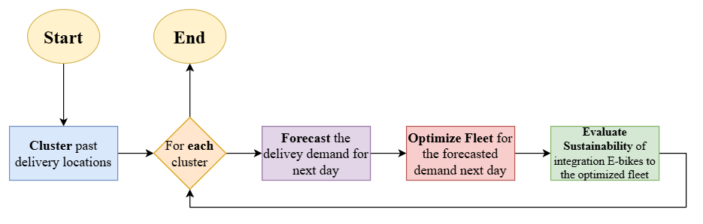
Figure 1 Research Methodology Framework

Data Collection
India is a good example for a country with variety of restaurants and most of them are doing the delivery operations through OFD services. With the government support of digitalization initiatives, restaurants in India have explored the opportunity of Platform Logistics for their deliveries. But the high commission rates from OFD platforms such as “ZOMATO” and “SWIGGY” has made the restaurants focus more on self-logistics favouring our model (Pattanshetty, 2023).
For this analysis, we used a dataset from Kaggle which holds many records of food delivery from different restaurants across India (Malik, 2022). The dataset contains 45593 detailed records of daily food delivery transactions, including order times, delivery duration, customer ratings, and restaurant details happened from 1st of March 2022 to 6th of April 2022. This dataset was selected due to its comprehensive nature and relevance to analysing food delivery patterns
Below features from the dataset will be used for the model creation.
Feature | Model Type
Restaurant latitude | Clustering/Fleet Optimizing
Restaurant longitude | Clustering/Fleet Optimizing
Delivery location latitude | Clustering/Fleet Optimizing
Delivery location longitude | Clustering/Fleet Optimizing
Order date | Demand Forecasting
Time ordered | Fleet Optimizing
Type of order | Fleet Optimizing
Type of vehicle | Fleet Optimizing
Table 1 Features used model wise

Data preprocessing

Predefined values
Before starting to analyse the data, we declare Start Date and End Date of the dataset and Start time and End time for each day. This could be important when the restaurant is trying to get a prediction for a separate time frame of the next day. For an example, deliveries and needed fleet configuration for next day between 5pm – 9pm, or to get a prediction using a specific date range like using 25 days before Christmas which could identify the seasonality well and makes this model more dynamic. For this analysis, we use the whole records by mentioning minimum and maximum date and time.
Start Date | 2022-03-01
End Date | 2022-04-06
Start Time | 00:01:01
End Time | 23:59:59
Table 2 Predefined Values
Further, if the restaurant needed a separate prediction for the order type, let’s say for “snacks”, they can use the records which has “snacks” and use the same model within above timeframe and get the prediction. If there is an abnormal scenario happening in the country, restaurants could use this part to get data from separate dates and separate times and run the model.

Handling data quality issues and filtering data
Data quality issues such as extra blanks on the data are removed and null values containing rows are dropped to avoid any discrepancies. We convert order date and order time data as date and time type variables to filter the data within the predefined Start and End Date and Times mentioned in 3.2.1 section. In the dataset, there are some records with “0.0” as latitudes and longitudes which are bad data. We need to remove those records. And we need to choose deliveries with values “scooter” and “motorcycle” in the “Type of Vehicles” column as we are focused to analyse integrating E-Bikes comparing with traditional motorcycle and scooter.

Restaurant location
This dataset contains delivery orders from many different restaurants. Since we are focused modelling on one restaurant, we need to identify which restaurant has maximum records, so we can use that restaurant for our model. For this, we need to group our records by restaurant location and get the count for each restaurant. Then we need to sort the count in descending order. Restaurant which has the highest count is chosen for our model. Then we need to choose the records only for that restaurant from the main dataset and create a new dataset which will be used in the next steps analysis.

Model development
Through extensive exploration of studies on various industries, we have identified the best and most promising algorithms and methods to use in this model development. They will be discussed in the next sub sections.

K-Means clustering to identify different clusters on delivery locations
K-Means Clustering algorithm is used in much customer centric research to classify the customer based on a measurement. (Abdullahi et al., 2024) explained the use of K-Means clustering, to identify the EV charging stations based on customer locations. We use the same approach in this section. As discussed in Section 2.3.1, past delivery locations needed to be separated into different clusters, so we can forecast the delivery demand for each customer cluster and optimize delivery fleet according to the predicted demand of the cluster. This is helpful for restaurants to identify what zone of their delivery area has more orders or less orders and how the fleet adjustments should be happened according to that. Mathematical formulation can be built as below,
Each delivery location $x_{i}$ is assigned to the closest cluster $c_{k}$ by minimizing the total squared distance.
$$J=\sum_{i=1}^{n}{\sum_{k=1}^{K}{w_{ik}{‖x_{i}-c_{k}‖}^{2}}}$$
Equation 1 Total clustering cost

Where,
$n$ = Total number of customer delivery locations,
$K$= Number of clusters (optimal number selected using silhouette scores),
$x$ = Set of delivery locations (latitude, longitude pairs),
$C$ = Centroids of each cluster,
$J$= Total clustering cost (sum of squared distances),
$w_{ik}$=$1$if delivery location $x_{i}$is assigned to cluster $k,$otherwise 0,
${\left\|x_{i}-c_{k}\right\|}^{2}$= Euclidean distance between delivery location $x_{i}$ and cluster centre $c_{k}$.
Algorithm 1 Clustering Delivery Locations using K-Means
Input: Delivery Locations (Coordinates) $L=\{l_{1}, l_{1}, …, l_{n}\}$, Number of Clusters $K$
Output: Cluster Assignments $C_{k}$
initialize $K$ cluster randomly;
repeat
for each location $l_{i}∈L$ do
Assign $l_{i}$ to the nearest cluster centroid
for each cluster $k∈K$ do
Update centroid by computing mean of all locations in $C_{k}$

until Centroids do not change significantly
return Final cluster assignments $C_{k}$ for each location

To find the optimal number of clusters we run the above algorithm for multiple values K and evaluate the silhouette coefficient(Dinh et al., 2019) for each K. Starting K Value and Ending K value might be managerial decision according to the needs and wants of the restaurant business. K value which holds the maximum silhouette coefficient will be considered as the optimal number of the clusters and each delivery will be assigned to a cluster. Separate datasets are created for each cluster as we need next analysis done for separate clusters.

Creating clustering model

Adding noise to customer locations
Since this is a public dataset even though we filtered the restaurant which had the highest number of deliveries from section 3.2.3, some deliveries are from the same customer. This will affect Clustering customer locations of deliveries and Delivery Fleet Size Optimization because we are dealing with customer locations, and it creates occurrences with same locations. Therefore, we will add a noise to customer location latitudes and longitudes to make every delivery a distinct customer. Since latitudes and longitudes are very sensitive data, a small noise is sufficient. We will draw samples random decimal number from a range between -0.05 and 0.05 which is uniformly distributed, to the current latitude and longitude values. Then, we will add noise to each coordinate in our dataset. But this operation is only for this dataset. If this full model is used to a real-world restaurant, they can disregard this section.

Normalizing customer locations
Since the customer locations of the deliveries or the delivery location latitudes and longitudes are eight digits and six decimal places, we must normalize the latitudes and longitudes values to equalizes feature scales and to enhances algorithm convergence. Using “Standard Scaler”, we scale with the mean and the standard deviation of the dataset created in section 3.3.1.1.1 using below formula.
$$z=\frac{x- μ}{σ}$$
Equation 2 Standard scaling
Where,
$x$ = original coordinates value,
$μ$ = mean of the coordinates values,
$σ$ = standard deviation of the coordinates values,
$z$ = standardized coordinates value.
We store the normalized values of latitudes and longitudes in the dataset as new columns which are inputs to the K-Means Clustering.

Creating K-Means clustering model
Using SciKit-Learn framework (Pedregosa et al., 2011) and information mentioned in section 3.3.1, we create K-Means Clustering model. First, we need to determine the optimal number of clusters (or the k value), that the customer locations fall. For that, we must run the K-Means model through multiple K-values and evaluate silhouette coefficient(Dinh et al., 2019) for each K value. Multiple K-Values are defined through a range. For this analysis, we have made the following, but they can be changed according to the restaurant management needs.
Start k | 2
Max k | 6
Table 3 K value range for clustering
As mentioned previously, scaled/normalized customer location latitudes and longitudes and the k value/number of clusters will be input to the model. By running the model to the range of each k value starting from starting k value and maximum k value, we get the relevant cluster as label for each customer delivery location as output. For each k -value, we will be able to get labels, so for each set of labels, we will be able to evaluate the silhouette coefficient. K value which has the highest silhouette coefficient value is chosen as the optimal k value or the number of clusters.
When it comes to this point, we have found the optimal k value / number of clusters and the cluster each delivery belongs. In the next steps, we will work with each cluster separately. Therefore, we need to store belonging cluster for each delivery in the dataset and this dataset will be used for prediction and fleet optimization for every cluster by just filtering the dataset by cluster.

LSTM to forecast the number of deliveries
After clustering the deliveries based on delivery locations, we can predict the demand for each cluster separately. So, the model can dynamically allocate fleet based on the number of deliveries for each cluster. This helps restaurant to cater their demand for different zones(clusters) of their delivery area differently.
As mentioned in section 2.3.2, Neural Networks are the ideal solution for this time series problem. Because of the dynamic nature of restaurants and non-linear patterns of demand, LSTM, a type of a Recurrent Neural Network can be used to predict the number of deliveries for a certain time for a restaurant. Much new research in demand forecasting has been done (Ubal et al., 2023)(Tanizaki et al., 2024)(Ubal et al., 2023) (Lazcano and Jaramillo-Morán, 2025) has been done using LSTM algorithm specially in restaurant sector. Even though LSTM needs High Computation, Seasonal Trends in restaurants can be captured accurately due to the better capacity of long-term memory. For our model, we have adopted LSTM and adjusted it to get the historical number of deliveries for each day and the day of the week as inputs and predict the deliveries for the next day. LSTM approach can mathematically explain as below.
At each time step $t$, given historical deliveries and day of week $x_{t}$ and hidden state $h_{t}$, the LSTM updates as follows:
Forget past information, $f_{t}=σ\left(W_{f}x_{t}+U_{f}h_{t-1}+b_{f}\right)$
Decide what to remember, $\begin{aligned}i_{t}=σ\left(W_{i}x_{t}+U_{i}h_{t-1}+b_{i}\right) \\ {\overline{c}}_{t}=tanh\left(W_{c}x_{t}+U_{c}h_{t-1}+b_{c}\right)\end{aligned}$
Update memory state, $c_{t}=f_{t}⊙c_{t-1}+i_{t}⊙{\overline{c}}_{t}$
Generate prediction, $\begin{aligned}o_{t}=σ\left(W_{o}x_{t}+U_{o}h_{t-1}+b_{o}\right) \\ h_{t}=o_{t}⊙tanh\left(c_{t}\right)\end{aligned}$
Equation 3 LSTM equations
Where,
$x_{t}$ = Number of deliveries on day $t$and day of the week,
$h_{t}$ = Hidden state representing delivery trends,
$c_{t}$ = Cell state storing long-term demand patterns,
$W,U,b$ = Trainable weight matrices and biases,
$σ\left(⋅\right)$ = Sigmoid activation function,
$⊙$ = Element-wise multiplication.

Below algorithm shows the process of LSTM forecasting for Restaurant deliveries. Each of the steps are discussed in the upcoming sections.
Algorithm 2 Delivery forecasting model for restaurants using LSTM
Input: Number of deliveries per day with date
Output: Number of deliveries for the next day
Preprocessing phase:
get day of the week as additional feature
Training phase:
for each combination of Bayesian Optimization
create sequences
split the sequence for train, validate and test
normalize the split sequences
initialize LSTM, optimizer, loss function
train the model and validate the model
endfor
return best model state and best parameters with minimum validation loss
Testing phase:
using best model state and best parameters,
initialize LSTM, optimizer, loss function
create sequences
split the sequence for train, validate and test
train the model and validate the model
test the model
denormalize the predictions
evaluate the model

return number of deliveries for the next day

Initialize the LSTM Model
Using PyTorch Framework (Paszke et al., 2019), we created our LSTM Model. Initializing the LSTM model, we declare below parameters,
Parameters | Description
Input size | The number of expected features in the input x. In our scenario, we hardcode this as 2 since we are dealing with two features which are number of deliveries per day and day of the week.
Output size | The number of expected predictions in the output y. In our scenario, we hardcode this as 1 since we are getting number of deliveries for the next day
Hidden size | The number of features in the hidden state h. For this parameter, we obtain the optimal value which gives the least loss from Hyperparameter Tuning discussed in section 3.3.2.8.
Number of layers | Number of recurrent layers. For this parameter, we obtain the optimal value which gives the least loss from Hyperparameter Tuning discussed in section 3.3.2.8.
Batch first | If True, then the input and output tensors are provided as (batch, seq, feature) instead of (seq, batch, feature). In this analysis, we make this true, because we need to get the hidden state of the last batch of the output, and we can easily get the last batch by using python slicing if we make this true.
Dropout | If non-zero, introduces a Dropout layer on the outputs of each LSTM layer except the last layer, with dropout probability equal to dropout. Since we have very highly fluctuated data, risk of overfitting increases. Therefore, dropout inside the LSTM model is needed to improve generalization of predictions. For this parameter, we obtain the optimal value which gives the least loss from Hyperparameter Tuning discussed in section 3.3.2.8.
Table 4 LSTM initializing parameters

Dropout layer
Since the deliveries are highly fluctuated across the date range, dropout layer after the LSTM, is needed since reduce overfitting and increase generalization. (Hinton et al., 2012) proves setting a dropout is an effective technique for regularization and preventing the co-adaptation of neurons. For this, we must define probability of an element to be zero. For this parameter, we obtain the optimal value which gives the least loss from Hyperparameter Tuning discussed in section 3.3.2.8.

Fully connected layer
To transform the last hidden layer output to output size of whole (which is 1), we use a full connected layer. This applies an affine linear transformation to the incoming data.
$$y=xA^{T}+b$$
Equation 4 Fully connected layer
We define the hidden size as $x$ and output size as $y$ that we are defining in section 3.3.2.1.1.

Defining forward function
Input sequences (created from the number of deliveries) which will be discussed in section 3.3.2.6 will be used as the input parameter for this function. And that input sequences will be input to the LSTM Model as well. Final output of the function/prediction will be created through Model’s output will be gone through dropout layer defined in section 3.3.2.1.1.1 and then full connected layer defined in section 3.3.2.1.1.2.

Preprocessing the data for LSTM
Since separate datasets are created for each cluster, we use them as input to the LSTM Model, but they need to be rearranged as time series data. For that, we will group the dataset by order date and get the count of deliveries for each date. Next, we sort the dataset according to the date ascending order and add zeros to a date if there were no deliveries. Now we have daily number of orders from the cluster data within the time frame we defined in section 3.2.1. Since we have the dates for each record, we add the day of the week feature for this data as an additional feature to increase the accuracy of the predictions.
Sunday | 0
Monday | 1
Tuesday | 2
Wednesday | 3
Thursday | 4
Friday | 5
Saturday | 6
Table 5 Day of week mapping
This time series data is used for the next steps of analysis.

Sliding window approach
We use sliding window approach to create the sequences of delivery data we created from section 3.3.2.2, as labels and the target values. Label values (number of deliveries, day of the week) will be the input to the model and target values will used for the lost function with model’s output. First, we determine the sequence length, like how many days of delivery data are we putting as labels/inputs in the sequence to achieve the target/next day number of deliveries. This could be a management decision as it can be changed due to ongoing trends and seasonality. But for this model, we obtain the optimal value which gives the least loss from Hyperparameter Tuning discussed in section 3.3.2.8. Labels and targets will be datasets; we use for the next steps of the models.
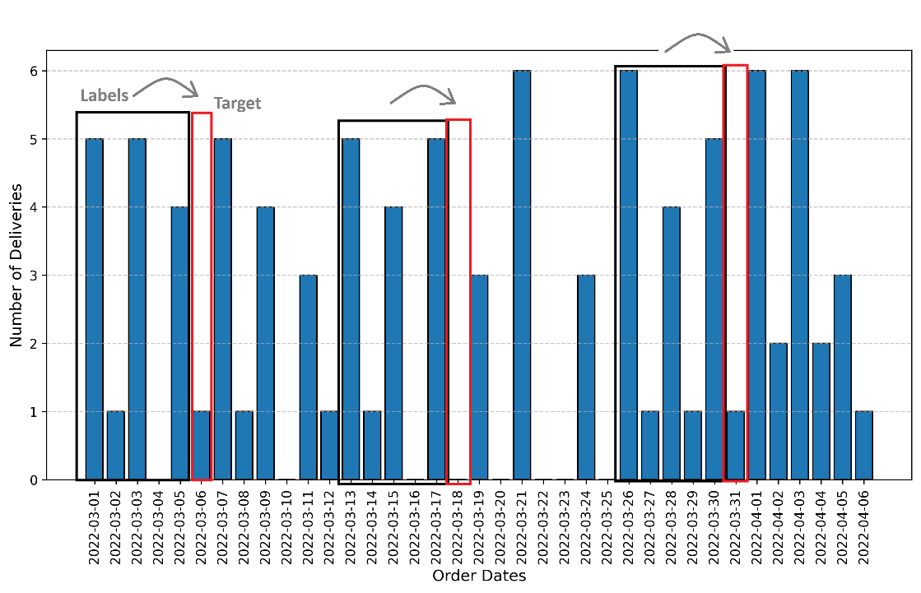
Figure 2 Sliding window approach

Training data, validating data and testing data
We divide the datasets (both label and target values) into two subsets. 70% of the dataset will be used as training dataset and rest 30% will be used as testing dataset. Testing dataset will be divided into two halves again. One half will be used as the validation dataset and the other half will be used as the testing dataset. In both these operations, we specifically do not shuffle the data, to preserve the time series quality of the data.

Scaling data for normalization
Since LSTM is a high computational approach, we scale the training, validating and testing data created in section 3.3.2.4 to make LSTM do the computation more easily and efficiently. For that, we use Min-Max scaling approach due preservation of the shape of the original distribution and does not reduce importance of outliers.
$$x^{'}= \frac{x-min⁡(x)}{\max\left(x\right)-min⁡(x)}$$
Equation 5 Min-Max scaling
Where,
$x^{'}$ = Normalized number of deliveries,
$x$ = Original number of deliveries.
For this analysis, we use Min-Max Scaling method. We need to scale labels and targets separately as they have different feature ranges and to ensure the model stability. First, we scale the training dataset first and apply same transformations on the validating and testing datasets. Scaled Data will be converted into tensors, which are a specialized data structure that are very similar to arrays and matrices, since we are using PyTorch, and to encode the inputs and outputs of a model, as well as the model’s parameters.

Loss function and optimizer
To evaluate how well our model's predictions match the true outcomes, we use Mean Squared Error as loss function which measures the mean squared error (squared L2 norm) between each element in the prediction and the target. To minimize the loss function by adjusting model parameters which are LSTM weights and Biases, we use “ADAM” as the optimizer. Three parameters needed to be setup for the optimizer. Model parameters, Learning rate and Weight decay(a regularization technique by adding a small penalty, usually the L2 norm of the weights (all the weights of the model)), will be parameters to the loss function which is mainly used to prevent model overfitting. For this model, we obtain the optimal value for learning rate and weight decay which gives the least loss from Hyperparameter Tuning discussed in section 3.3.2.8.

Hyperparameters
For this model, sequence length, hidden size, learning rate, number of layers, LSTM dropout, FC dropout, epochs, weight decay which are discussed in the previous sections, are identified as hyperparameters. And we have specified the parameter boundaries which is the range for each hyperparameter.
Hyperparameter | Parameter Boundaries
Sequence length | [2, 5)
Hidden size | [2, 512)
Learning rate | (0.01, 0.1)
Number of layers | [1, 5)
LSTM dropout | (0.0, 0.5)
FC dropout | (0.0, 0.5)
Epochs | [100, 600)
Weight Decay | (1e-06, 1e-02)
Table 6 Hyperparameter parameter boundaries
Using Bayesian Optimization discussing in section 3.3.2.8, we find the best values for each hyperparameter within parameter boundaries which the model provides the least loss function output.

Best hyperparameters using Bayesian optimization
As stated on the table, we use a range of values for each hyperparameter, and best parameters are determined through Bayesian Optimization. For the Bayesian Optimization, we use the Bayesian optimization program written by (Nogueira, 2014). It tries many combinations using range of hyperparameter range given in 3.3.2.4 table by training the model using training dataset for each combination and evaluate the training process using validating dataset by measuring the validation loss. Combination which gives the least validation loss will be identified as the best parameters and used to test the LSTM model finally. For this analysis, we define 100 iterations of optimization, which is ideal since we are dealing with limited parameter boundaries of hyperparameters. These two parameters can be changed according to management decisions or the model run times.

Training and testing the LSTM model
After determining the best parameters, we create the sequences, initialize the model, loss function and optimizer using best parameters. Then we train the model using the best parameters, using training dataset and validate the model using validating dataset at the same time. In this operation we measure the training loss and as well as the validation loss simultaneously. When training, we look for the least validation loss and save the model’s state at that point. which will be restored when testing the data. After training, we will restore the best state of the model which gave the least validation loss and test the model using our testing dataset. From this we get the predictions for the testing labels. Using them and actual targets, we evaluate the testing using loss function, but the loss is given to our scaled data, because the datasets we used, still are scaled for normalization as in section 3.3.2.5.

Denormalization of testing data labels and predictions
At this point, we have tested the model using testing labels and we got the predictions, and we have the actual targets. But both are scaled or normalized. Now we need to denormalize them back to original values. Since we had separate scalers for labels and targets, we need to use same target scaler to get the original values of predictions and the actual targets.

Evaluation Metrics
Since we are working on a time series prediction, we have many evaluation metrics compared to other analysis. For this analysis, we use MSE, RMSE, R2 Score, MAE and Pearson Correlation Coefficient. This metrics are very useful for us and management to make decision whether the model did well on the testing data.

MSE
It used to measure the average squared difference between the predicted values and the actual values in the dataset.
$$MSE = \frac{1}{n}\sum_{i=1}^{n}{{(Y_{i} -\hat{Y_{i}})}^{2}}$$
Equation 6 MSE
Where,
$n$ = Number of data points,
$Y_{i}$ = Actual values,
$\hat{Y_{i}}$ = Predicted values.

RMSE
It measures the square root of the average squared difference which shows standard deviation of the residuals.
$$RMSE = \sqrt{\frac{1}{n}\sum_{i=1}^{n}{{(Y_{i} -\hat{Y_{i}})}^{2}}}$$
Equation 7 RMSE
Where,
$n$ = Number of data points,
$Y_{i}$ = Actual values,
$\hat{Y_{i}}$ = Predicted values.

R2 Score
R2 is a measure of the goodness of fit the model. In regression, the R2 coefficient of determination is a statistical measure of how well the regression predictions approximate the real data points.
$$R^{2}= 1 - \frac{RSS}{TSS}$$
Equation 8 R2 Score
Where,
$RSS$ = Sum of squared of residuals,
$TSS$ = Total sum of squares.

MAE
MAE is a measure of the average size of the mistakes in a collection of predictions, without taking their direction into account
$$MAE = \frac{1}{n}\sum_{i=1}^{n}{\left|{\hat{Y_{i}}- Y}_{i}\right|}$$
Equation 9 MAE
Where,
$n$ = Number of data points,
$Y_{i}$ = Actual values,
$\hat{Y_{i}}$ = Predicted values.

Peason correlation coefficient
The Peason correlation coefficient measures the linear relationship between two datasets. Like other correlation coefficients, this one varies between -1 and +1 with 0 implying no correlation. Correlations of -1 or +1 imply an exact linear relationship.
$$r = \frac{\sum{(Y_{i}- \overline{Y_{i}})\sum{(\hat{Y_{i}}- \overline{\hat{Y_{i}}})}}}{\sqrt{\sum{{(Y_{i}- \overline{Y_{i}}) }^{2}\sum{{(\hat{Y_{i}}- \overline{\hat{Y_{i}}}) }^{2}}}}}$$
Equation 10 Peason correlation coefficient
Where,
$Y_{i}$ = Actual values,
$\overline{Y_{i}}$ = Mean of actual values,
$\hat{Y_{i}}$ = Predicted values,
$\overline{\hat{Y_{i}}}$ = Mean of predicted values.
For each cluster we go through these steps, and we can have a dynamic model which can predicts the number of deliveries for the next day. This output will help the restaurant to determine the how much resource allocation should be happened for the delivery component specifically for each customer segment based on the location. Number we get as the predicted delivery demand will be an input for the Synthetic location data generation.

Hybrid location data generation
Let’s say we got $N_{\text{Predicted Deliveries}}$ number of deliveries as prediction. Even though we did predict next day number of deliveries, we cannot tell what customer from what location will order these deliveries. Therefore, we generate hybrid delivery locations based on historical delivery data which is mixture of historical and synthetic locations. Since we have separate datasets for each cluster, we take each dataset and generate a mixture of historical and synthetic locations of customers locations which makes analysis more accurate. Historical means the existing customers and synthetic means new customers. Since we are working with multiple clusters, we need to do this analysis discussed in section 3.3.3.1 and 3.3.3.2 for each clusters dataset we had at end of section 3.3.2.

Historical locations generation
Historical Locations means, we can expect a customer ordered from the restaurant before will order a delivery again. But that number can determine using the mean of the number of deliveries we got for each day if we assume the mean of number of deliveries will always occur and they will be existing customers. For each cluster, we have number of deliveries for each day. From that number of deliveries, we calculate the average number of deliveries or the mean of the dataset and round down to the nearest integer $N_{\text{Historical} }$, because we need to more priority on synthetic generation. Then we are randomly taking $N_{\text{Historical} }$number of deliveries from the cluster’s dataset.

Synthetic locations generation
Synthetic Locations are the new delivery orders which the restaurant expects in the next day within the number of predicted deliveries. Synthetic Remaining proportion from the predicted number of deliveries will be generated through synthetic generation of locations, and the order times and order type are randomly taken from historical data for the sake of accuracy of the time frames.
$$N_{\text{Synthetic} }=N_{\text{Predicted Deliveries}}- N_{\text{Historical} }$$
Equation 11 Number of synthetic deliveries
Where,
$N_{\text{Synthetic }}$ = synthetically generated deliveries
Synthetic Generation can be mathematically explained as below:
A new delivery location $x^{'}$ is sampled from a multi variate normal distribution centered around the cluster’s past delivery points:
$$x^{'}∼N\left(μ,Σ\right)$$
Equation 12 Multi variate normal distribution
$$where:-$$
$μ=\left(μ_{x},μ_{y}\right)$ = Mean coordinates of historical data delivery locations in the cluster
$Σ$ = Spread (covariance matrix defining variation in locations)
For this model, we have used 0.003 as Spread since we are generating latitudes and longitudes, and they are very sensitive for decimal places.
Since we generate the new synthetic centered around the past delivery locations, first we need to find the centroid of delivery locations. We synthetically generate $N_{\text{Synthetic }}$ number of new delivery locations.
Final dataset generated from this section will be used as the input for Vehicle Route Optimization to optimize the delivery fleet for the predicted deliveries next day.
Final dataset of detailed predicted deliveries $X_{\text{final }}$can be explained as below.
$$X_{\text{final} }=X_{\text{real} }+X_{\text{synthetic} }$$
Equation 13 Final dataset
$where:-$
$X_{\text{real }}$= historical deliveries
$X_{\text{synthetic }}$= synthetically generated deliveries
$X_{\text{final }}$ for each cluster will be the input to delivery fleet optimization process discussed in section 3.3.4.

Delivery fleet optimization
Once feasible deliveries for the predicted number of deliveries are available from section 3.3.3, we determine the best way to achieve those deliveries by using minimal fleet. For this concern, we use a customized approach for restaurant deliveries by combining vehicle routing problem with time windows, capacities and distance constraints. Because as explained in section 2.4.1, 2.4.2 and 2.4.3, time windows of the orders, carrying capacities and distance range of the delivery vehicle should be taken into consideration when designing the optimized fleet for the restaurant deliveries. Mathematical Formulation of the customized VRP for restaurant deliveries can be explained as below:
Objective: Minimize total distance
$$min\sum_{v∈V}{\sum_{i∈N}{\sum_{j∈N}{d_{ij}x_{ijv}}}}$$
Equation 14 VRP objective function
Constraints:
- Each delivery must be assigned exactly once
$$\sum_{v∈V}{\sum_{j∈N}{x_{ijv}=1, ∀i∈N}}$$
- Vehicles must return to the restaurant
$$\sum_{j∈N}{x_{ijv}}=\sum_{j∈N}{x_{jiv}},∀i∈N, v∈V$$
- Vehicles cannot exceed their load limit
$$\sum_{i∈N}{c_{i}x_{ijv}}≤C_{v}, ∀∈V$$
- Deliveries must be completed within allowed time windows
$$T_{i}≤t_{i}≤T_{j}, ∀i,j∈N$$
- Vehicle trips cannot exceed maximum allowed distance
$$\sum_{i∈N}{\sum_{j∈N}{d_{ij}x_{ijv}}}≤D_{v}, ∀v∈V$$
Equation 15 VRP Constraints
Where,
$N$ = Set of delivery locations,
$V$ = Fleet of delivery vehicles,
$d_{ij}$ = Distance between delivery locations $i$ and $j$,
$t_{ij}$ = Travel time from $i$ to $j$,
$x_{ijv}$ = 1 if vehicle v travels from $i$ to $j$ ,otherwise 0,
$C_{v}$ = Capacity of vehicle $v$,
$D_{v}$ = Maximum allowed travel distance per vehicle.

Algorithm 3 Optimizing Fleet using Customized VRP for restaurant deliveries
Input: Delivery Locations (Coordinates) $L=\{l_{1}, l_{1}, …, l_{n}\}$, Vehicle fleet $V$ with carrying capacity $C_{v}$, orders $d_{i},$ Distance range of vehicle $D_{v}$, Time windows of deliveries $t_{d}$, Duration Matrix $T$, Distance Matrix $D$
Output: Optimized route $R_{v}$ for each vehicle $v∈V →$ Optimized Fleet
for each vehicle $v∈V$ do
initialize vehicle load $L_{v} ←0$ and time elapsed $T_{v} ←0$;
select starting location $l_{0}$ (restaurant)
while unserved locations remain do
find nearest unserved location $l_{i}$ from current position using $D_{current, i}$
if ($L_{v}+ d_{i}≤ C_{v})$ and
($t_{start}+ T_{current,i}≤ t_{end})$ and
${(t}_{start}+ T_{current,i}≤ t_{end}$ then
assign $l_{i}$ to vehicle route $R_{v}$
update vehicle load $L_{v} ← L_{v}+ d_{i}$
update time ${(t_{d} ← t}_{d}+ T_{current,i})$
mark $l_{i}$ as served
else
return vehicle $v$ to restaurant to start a new route
return vehicle $v$ to depot after completing route $R_{v}$
endfor
return Optimized route $R_{v}$ for each vehicle $v∈V →$ Optimized Fleet

Preprocessing for VRP

Predefined values for VRP
First, we define the Opening Time and Closing time of the restaurant to make sure all the deliveries happened within that time frame or the time window. Additionally, we have added another 40 minutes to the closing time of the restaurant work on the last-minute orders.
Restaurant Opening Time | 10:00:00
Restaurant Closing Time | 23:59:59 + 40 Minutes = 00:39.59(next day)
Table 7 Predefined values for VRP
We have defined the delivery time of a meal as a standard of 40 minutes. But this can be changed according to the distant orders and make slight adjustments to the delivery time. Using the dataset, we created 3.3.4, A new column is created as “Time Delivered” by adding the 40 minutes to “Time Ordered”, a data we already had from the first steps.
Maximum Number of Vehicles is also defined before running the VRP Model. This can be a managerial decision as well. But for this model, first, we assign a single vehicle for each delivery and add small excess number of vehicles. If the predicted number of deliveries is 6, we make the 6+3(excess) = 9 as the maximum vehicles and let the model optimize the number of vehicles by checking the constraints.

Time windows into total seconds
“Time Ordered” and “Time Delivered” columns are used as Start and End of the time windows. But since they are Time type data, we need to create them in a sequential aspect of time. Therefore, we convert times into seconds. For example, if a time is 13.40, we convert it to “49200” as the total seconds for that time, which is easy for the VRP model to process time windows.

Order type conversion
In the dataset used for VRP model, type or order column has labels which describes the actual meal, customer ordered. But this needs to be evaluated quantitatively, since we are using this field as demands to optimize capacity of the e-bike in the VRP model because we consider carrying capacity as a constraint and an input to the model. Therefore, we mapped the meals into a numerical value which closely shows their weight as we are working with capacity of the e-bike and the demand is measured for the weight of the meal.
Meal Type | Assigned Weight
Snack | 1
Drinks | 2
Meal | 3
Buffet | 4
Table 8 Order type mapping

Travel time and travel distances between customers and restaurant
Since we have the new delivery locations latitudes and longitudes from section 3.3.3 and we know the restaurant locations latitude and longitude, we can retrieve the travel distance and travel time between the delivery locations and restaurants using Google Distance Matrix API. This API will accept our latitudes and longitudes as inputs and send us the distance and time information in matrix form which will have travel distances and travel times between each location including restaurant. These distances and times are sent in SI units which means distances in meters and travel times in seconds. Distance Matrix and Time Matrix created from this section will be another two inputs to the VRP model.

Ensure deliveries can be achieved
After generating travel distances and travel durations matrices, we need to check whether there are deliveries which cannot be achievable within the Time of Delivery and the travel duration is matched to that location from the restaurant is matched. This is to ensure every delivery is achievable from the restaurant without optimizing fleet using a single vehicle. That’s a must before optimizing the fleet, Because the route optimization process fails if there any deliveries which cannot be achievable even through a single vehicle without the optimization as this is implied. Otherwise, the creating customized VRP model would fail. Therefore, first we find deliveries in both clusters which cannot be achievable by using travel durations and time of delivery which is time ordered plus 40 minutes. Then we track and modify the time windows of the delivery by adding travel duration from the restaurant to location, to the time ordered. Now we will have feasible deliveries which are achievable.
Algorithm 4 Check predicted deliveries are feasible with Time Durations from Restaurant
Input: Time Windows of the deliveries ${(t}_{start},t_{end})$, Duration Matrix $T_{0j}$ (from restaurant)
Output: Feasible Time Windows of the deliveries
for each ${(t}_{start},t_{end})$
if $t_{end}$ < $t_{start}$ + $T_{0j}$
$t_{end}←t_{start}+ T_{0j}$
else
continue
endfor

E-Bike type
According to Section 2.4.2 and 2.4.3, we should consider the Capacity and Distance Range of the E-Bike as an input when we create the VRP Model for a restaurant delivery fleet. Capacity and Distance Range changes with E-Bike types. Therefore, for this analysis, we identified 3 E-Bike lease/sell service providers around the world from 3 different countries who rent/sell e-bikes for food deliveries. And from each provider we chose either one or two e-bike types depending on the availability for our analysis and feed them as inputs to our model separately provider wise. These 3 E-Bikes will be discussed in section 4 as case studies.

Create the VRP model
To create this model, we adopt and change, routing modules of Google OR Tools according to the constraints we have mentioned in section 3.3.4. This model will accept duration matrix and distance matrix between the restaurant and delivery locations, time windows of the deliveries, order types, carrying capacity and distance range of e-Bike and the Vehicle count as parameters. (mention this model takes the cheapest bike output if the objective is equal)

Combinations for grid search using all bike types
By taking one E-Bike model at a time mentioned section 3.3.4.3.1 to 3.3.4.3.3, we generate all possible combinations of capacity, maximum travel distance, and varying fleet sizes (from 1 up to the maximum number of vehicles (defined in section 3.3.4.1.1) for each model). These combinations will be one of the inputs for the VRP Model.

Running the VRP
As fixed inputs, time windows of the deliveries from section 3.3.4.1.2, order types or demands from section 3.3.4.1.3, duration and distance matrices of the delivery locations (including restaurant) from section 3.3.4.2 will be used when running the VRP Model. As variable inputs, capacity and distance range of the e-bike and number of the e-bikes of the fleet generated through section 3.3.4.4 will be used when running the VRP Model. By running the VRP Model for different combinations of variable inputs, the VRP model will give the optimized number of E-Bikes along with the least cost E-Bike model. This is because we prioritize the least cost e-bike model. As additional outputs, the optimized routes for the generated deliveries from section 3.3.3 and distances travelled by each E-Bike of that routes will be given. This additional output can be used as input for section 3.3.5 to evaluate the sustainability of integrating e-bikes compared to traditional motorcycle and scooter.

Sustainability evaluation of integrating E-Bikes

Energy consumption of E-Bikes
E-Bike types we chose, are running from different capacities of batteries. Because of that, the distance range and carrying capacities are changed as explained in section 4 E-Bike types (EBIKE4DELIVERY, 2025) (EVEEZ, 2020) (RODHA AT, 2022).
E-Bike Provider | E-Bike Type | Battery Capacity (kWh)
EBIKE4DELIVERY | Gen3 | 0.9
 | Gen2+ | 0.72
EVEEZ | “SHINE” plan | 1.7
 | “BLAZE” plan | 2.2
RODHA | Founder’s Edition | 0.5
Table 9 Batter capacity of E-Bikes
Energy consumption of E-Bike can be derived using below formula.
$$Energy Consumption= C × \frac{D_{route}}{D_{max}}$$
Equation 16 E-Bike energy consumption
Where,
$C$ = Battery capacity (kWh),
$D_{route}$ = Route distance,
$D_{max}$ = Distance range of E-Bike.
Carrying Capacity of E-Bike is not taken to this equation because the manufacturer has mentioned total distance range of each bike along with the carrying capacity and battery capacity. That means deliveries which are already within the carrying capacity are already involved when the manufacturer designs the distance range of the e-bike and the battery capacity. To ensure that all deliveries are within the carrying capacity of the e-bike we have configured our model as already mentioned in section 3.3.4.1.3.

CO2 emissions saved
From the total distance for each E-Bike, we got from section 3.3.4.5, we can evaluate how much CO2 emissions have been reduced and how much energy has been saved. If we use a traditional motorcycle or a scooter, 103g-CO2 will be emitted per a passenger kilometre. Total Emitted CO2 Amount can be derived from below formula. (Matsuyuki et al., 2024)
$$E_{{CO}_{2}} = D_{travel} × E_{\frac{{CO}_{2}}{km}}$$
Equation 17 CO2 emission saved
Where,
$E_{{CO}_{2}}$ = CO₂ emissions
$D_{travel}$ = Travel distance
$E_{\frac{{CO}_{2}}{km}}$ = CO₂ Emissions per passenger kilometer
Since E-Bikes doesn’t emit any gas, no environmental pollution is happening through them.

CHAPTER – CASE STUDY ON E-BIKES

EBIKE4DELIVERY
For this analysis, we use “EBIKE4DELIVERY”, a lease/buy e-bikes service provider from Netherlands as the case study. With a slogan says, “World’s Strongest Delivery EBikes”, “EBIKE4DELIVERY” is available over 22 countries in Europe. Restaurants such as “SUBWAY”, “Dominos”, “McDonalds” and “BurgerKing” and many more has partnered with “EBIKE4DELIVERY” for their delivery operations. To the VRP Model, we are creating, we use the two e-bike models “Gen3” and “Gen2+” from “EBIKE4DELIVERY”. “Gen3” e-bike have a distance range up to 90km and a carrying capacity of 30kg. “Gen2+” e-bike have a distance range up to 60km and carrying capacity of 30kg. “EBIKE4DELIVERY” mentions in their FAQ, that “Leasing” is the ideal way compared to buying, because according to their words, “Leasing offers predictable costs, including maintenance, repairs and insurance. It avoids high purchase costs and offers flexibility to upgrade to newer models”. This further proves findings about leasing the delivery fleet, in the latter part of section 2.2.2. When it comes to pricing, Gen3 can be leased for 36 months for €149.00 and Gen2+ can be leased for 36 months €149.00. These costs are covering many more services such as maintenance and insurance, as it’s mentioned in their website (https://www.ebike4delivery.com/plans) (EBIKE4DELIVERY, 2025).
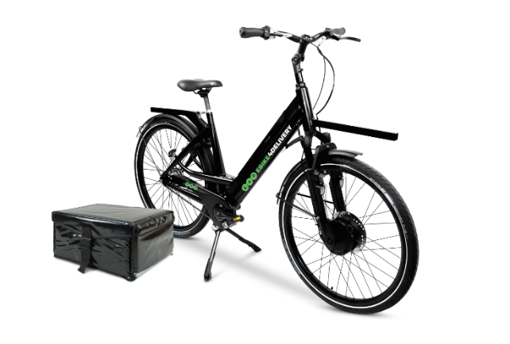
Figure 3 EBIKE4DELIVERY Gen2+ E-Bike
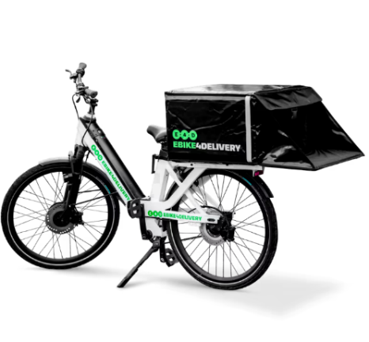
Figure 4 EBIKE4DELIVERY Gen3 E-Bike

EVEEZ
“EVEEZ” is another e-bike lease service provider from India which has a huge customer base of delivery services all over the country. “Zomato” and “SWIGGY” are one of the most famous food delivery services in India and they integrate E-bikes from “EVEEZ” for their services. “EVEEZ” is based on subscription plans. In their website, they have 5 subscription plans, which has 5 different E-Bikes, which has different ranges and carrying capacities. “EVEEZ” even has Custom Delivery Vehicles if needed which is ideal for restaurants. Since all their plans included with Insurance and Maintenance, Restaurants have nothing to worry about after services. For this analysis, we will be using “SHINE” plan and “BLAZE” plan and its’ bikes. “SHINE” plan e-bike has a range of 100km and carrying capacity of 70kg. “BLAZE” plan e-bike has a range of 60km and carrying capacity of 120kg (EVEEZ, 2020).
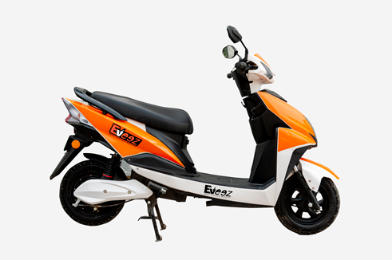
Figure 5 EVEEZ SHINE plan E-Bike
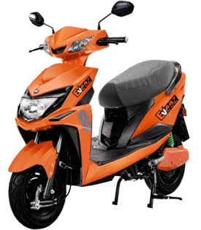
Figure 6 EVEEZ BLAZE plan E-Bike

RODHA
Representing Sri Lankan Initiatives, we use “RODHA”, a Sri Lankan lease/buy e-bikes service provider started their operations with the Covid-19 Pandemic. Food Delivery Services in Sri Lanka such as “PickMe” has started using “RODHA” for their daily operations due to sustainability initiatives taken by the Sri Lankan Government. Sri Lankan Restaurant are pushed from the government to integrate more sustainable practices to their and integrating “RODHA” will be an ideal solution. For this analysis and to the VRP Model, we use their “Founders Edition” Type which is the first Smart E-Bike produced in Sri Lanka. This type has range of 60km and a carrying capacity of 25kg. They have both lease and sale options for their E-Bike. But due to the Economic Crisis and After pandemic Effects, they have been pushing their customers to use their lease option as it can be leased daily and monthly. Their daily starts at Rs675, which is a feasible amount for a Sri Lankan (RODHA AT, 2022).
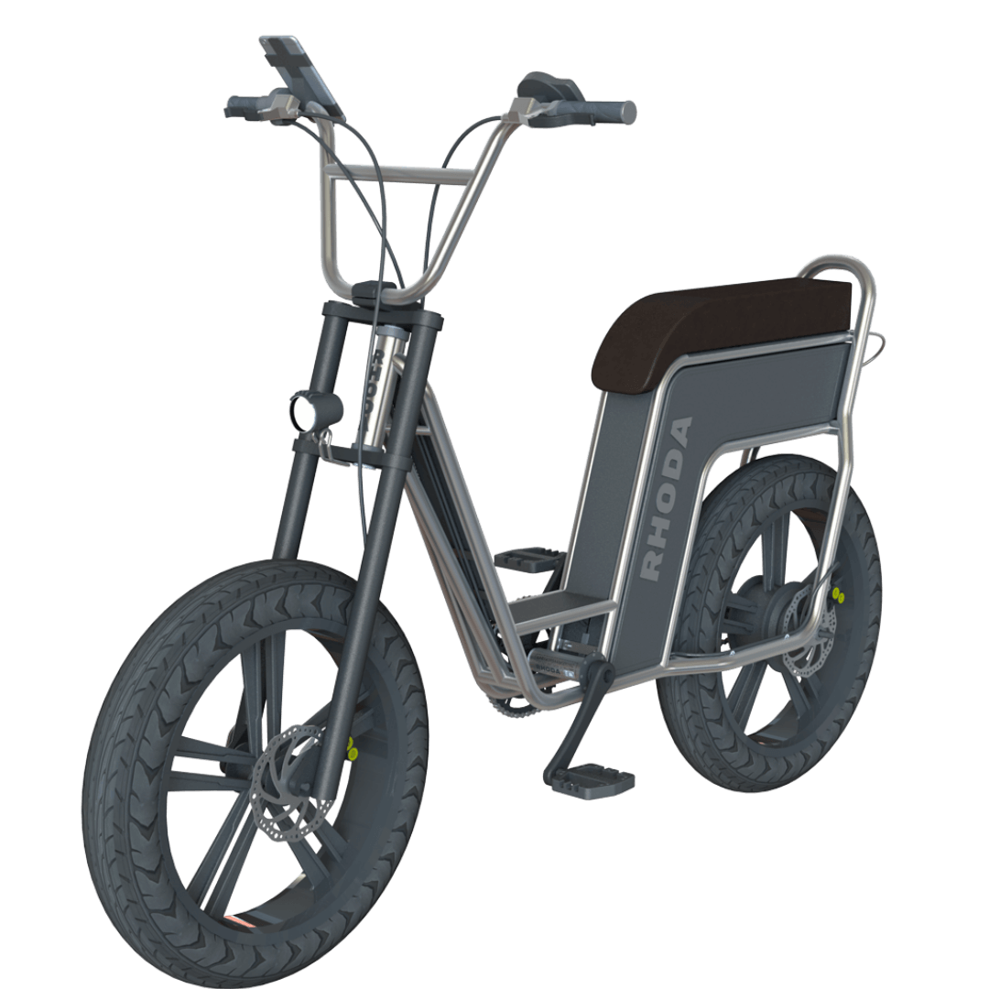
Figure 7 RODHA Founders edition
Service Provider | E-Bike model | Distance range(km) | Carrying capacity(kg)
EBIKE4DELIVERY | Gen2+ | 90 | 30
 | Gen3 | 60 | 30
EVEEZ | SHINE | 100 | 70
 | BLAZE | 60 | 120
RODHA | Founders Edition | 60 | 25
Table 10 E-Bike model summary

CHAPTER - RESULTS
After developing the complete model, we were able to test the model from clustering customer locations, predicting the number of deliveries per each cluster and optimize the delivery fleet for each cluster and results can be explained as below. For this analysis, we used Python as the programming language. Below python frameworks and modules for each relevant process.
- Data preprocessing – Numpy / Pandas
- Clustering – SciKit-Learn
- LSTM forecasting – PyTorch
- Bayesian optimization - bayesian-optimization
- Data scaling – SciKit-Learn
- Model performance metrics – SciKit-Learn / SciPy
- Synthetic location generation – SciPy
- Customized VRP – Google OR Tools

Restaurant with most deliveries
Since the original dataset had delivery records from many restaurants. Since this model is focues on one restaurant we need to sort determine which restaurant be used from the dataset. Since we are forecasting the number of deliveries for the we had to choose the restaurant with the greatest number of deliveries and get records to the next step of analysis. After preprocessing as mentioned in section 3.2.3, we were able to get the restaurants and number of deliveries in the descending order.
Restaurant latitude | Restaurant longitude | Count
26.911378 | 75.789034 | 175
26.902908 | 75.792934 | 164
22.308096 | 73.167753 | 162
26.88842 | 75.800689 | 162
26.892312 | 75.806896 | 162
Table 11 Restaurant with most deliveries
From this, we chose the Restaurant which the latitude is 26.91137 and the longitude is 75.789034 and chose the records from the main dataset only for that restaurant for the next steps of analysis.

Adding noise to the Customer locations
After choosing the restaurant with most deliveries, deliveries for this restaurant were from the same customer. Below is the first 10 records of the dataset.
Delivery location latitude | Delivery location longitude
26.921378 | 75.799034
26.981378 | 75.859034
27.051378 | 75.929034
26.951378 | 75.829034
26.941378 | 75.819034
26.941378 | 75.819034
27.051378 | 75.929034
27.051378 | 75.929034
26.951378 | 75.829034
26.991378 | 75.869034
Table 12 Before adding noise to the dataset
Therefore, we needed to add a noise as mentioned section 3.3.1.1.1. Delivery Locations got slightly change after adding the noise.
Delivery location latitude | Delivery location longitude
26.90883201 | 75.80024331
27.02644943 | 75.83168358
27.07457739 | 75.94355128
26.96124385 | 75.79647064
26.90697986 | 75.83812777
26.90697745 | 75.80770753
27.00718636 | 75.972707
27.08799561 | 75.89278609
26.9614895 | 75.81314064
27.01218526 | 75.83038135
Table 13 After adding noise to the dataset
Now we have unique customer for each delivery and unique delivery location for each delivery. This new dataset will be used for clustering next step.

Clustering the Customer Locations
Using K-Means Clustering model we created as section 3.3.1; we ran the model from start k values to maximum k values and got the silhouette coefficient for each k value as below.
K | Silhouette scores
2 | 0.453414
3 | 0.394223
4 | 0.414164
5 | 0.371535
6 | 0.348511
Table 14 Silhouette coefficient result
From the results, we were able to identify that when k=2, we get the maximum silhouette coefficient. From that and as mentioned in 3.3.1.2, we can determine that 2 is the optimal number of clusters and the customer locations can be divided into 2 zones according to the clustering labels ‘0’ and ‘1’.
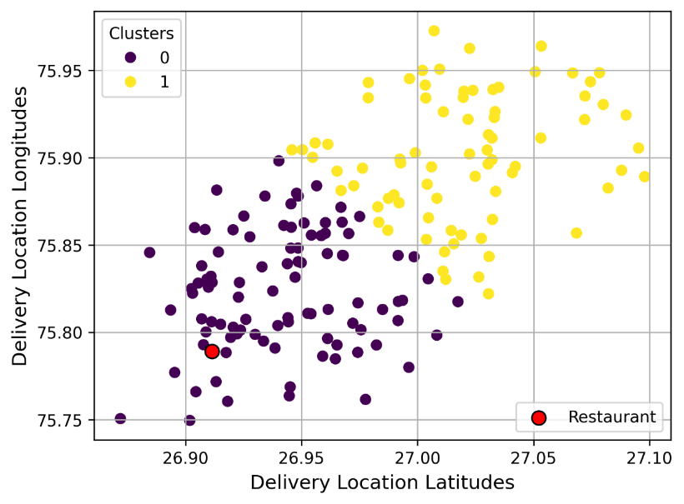
Figure 8 Clustering delivery locations result
These labels were saved in the dataset for next steps of analysis since we are analysing the clusters separately.

Number of deliveries for each Cluster
After filtering the dataset by each cluster, we have created below bar charts shows number of deliveries for each cluster. They have a minimum of zero deliveries and maximum of 6 deliveries.
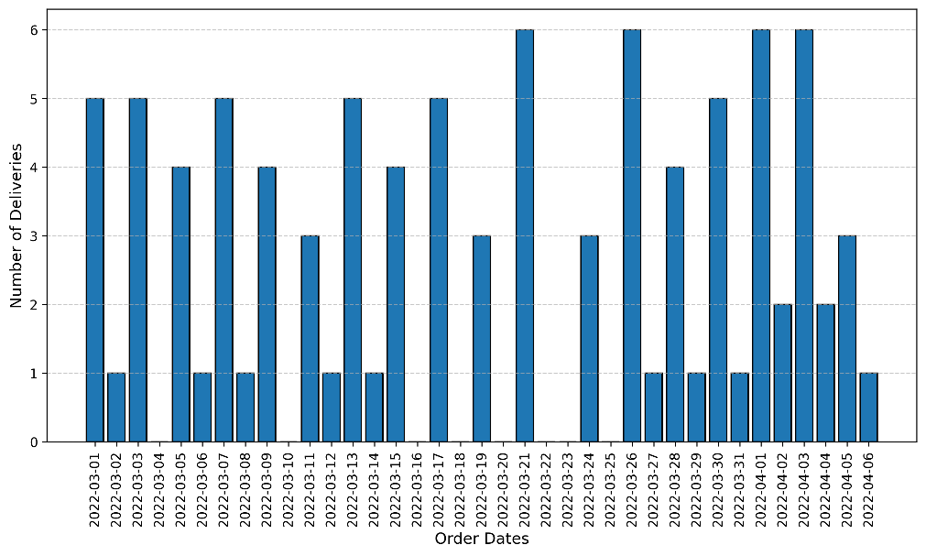
Figure 9 Cluster 0 number of deliveries
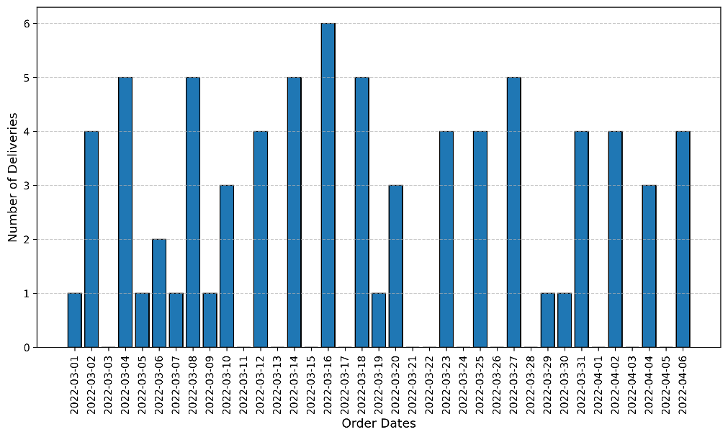
Figure 10 Cluster 1 number of deliveries
These data were formatted using “Sliding Window Approach” as mentioned in section 3.3.2.3 for labels and targets and added day of week feature as discussed in section 3.3.2.2. They were split into training data, validating data and testing as section 3.3.2.4. and will be the used to train and test LSTM prediction model.

Running Bayesian Optimization for hyperparameter tuning
Our LSTM prediction model will have 8 hyperparameters as mentioned in section 3.3.2.7., which needed to be optimized for the minimum loss of the output. Before testing the model, we need to identify the optimal values for each parameter. Therefore, using section 3.3.2.8 parameters, we ran the Bayesian optimization program on the LSTM prediction model and below values were selected as the optimal values for each hyperparameter for the two clusters.
Cluster | Epochs | FC dropout | Hidden size | Learning rate | LSTM dropout | Number of Layers | Sequence Length | Weight Decay
Cluster 0 | 213 | 0.0184 | 156 | 0.0552 | 0.0257 | 2 | 4 | 0.000025
Cluster 1 | 102 | 0.0804 | 141 | 0.0723 | 0.326 | 1 | 4 | 0.000024
Table 15 Optimal values for hyperparameters

Training, validating and testing data for the prediction
Since we acquired the optimal sequence length using Bayesian Optimization for both clusters, we did split the number of deliveries time series data as mentioned in section 3.3.2.4. Below tables will show number of sequences which will used for training, validating and testing in the next steps for both clusters.
Cluster | Total Datapoints | Training Datapoints | Validating Datapoints | Testing Datapoints
Cluster 0 | 33 | 23 | 5 | 5
Cluster 1 | 33 | 23 | 5 | 5
Table 16 Data split summary

Testing the predictions
Optimal Hyperparameters which we got from Bayesian Optimization is used again to reinitialize the LSTM Model. Then we trained the model again and validated model while training. Below graphs show the training loss and validating loss for each cluster.
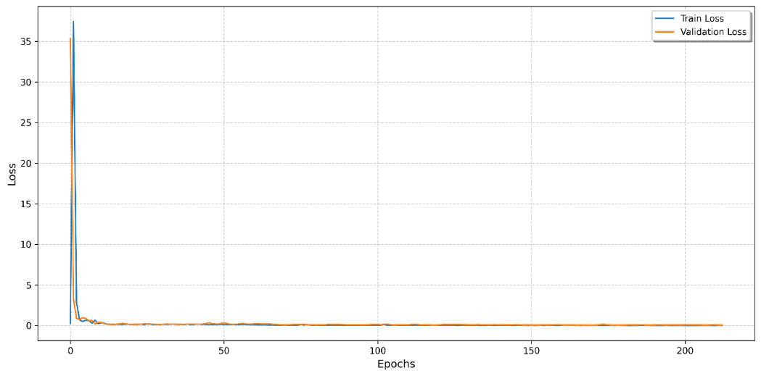
Figure 11 Cluster 0 loss curve
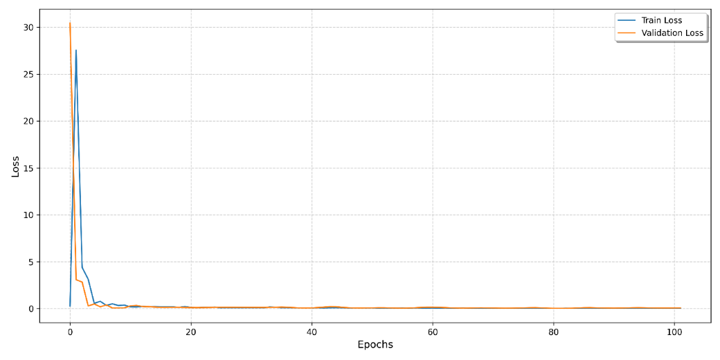
Figure 12 Cluster 1 loss curve
We saved the model state (weights and biases) when the model gave the least validation loss. After the training, we restored the saved model and tested using the testing data. We have plotted the results against the actual values and calculated MSE, RMSE, MAE, R2 Score and Peason’s Correlation Coefficient.
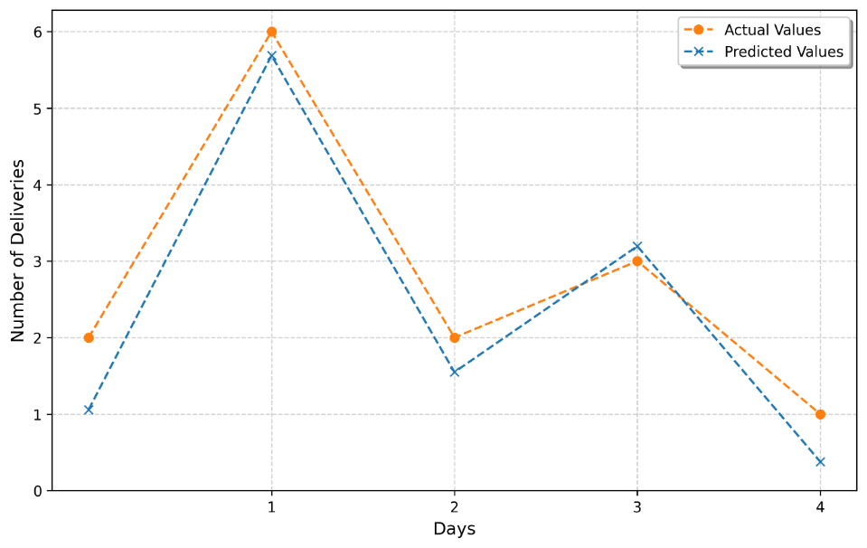
Figure 13 Cluster 0 prediction
MSE Loss | RMSE Loss | MAE Loss | R2 Score | Pearson's Correlation Coefficient
0.3231 | 0.5684 | 0.5046 | 0.8908 | 0.9834
Table 17 Cluster 0 prediction evaluation metrics
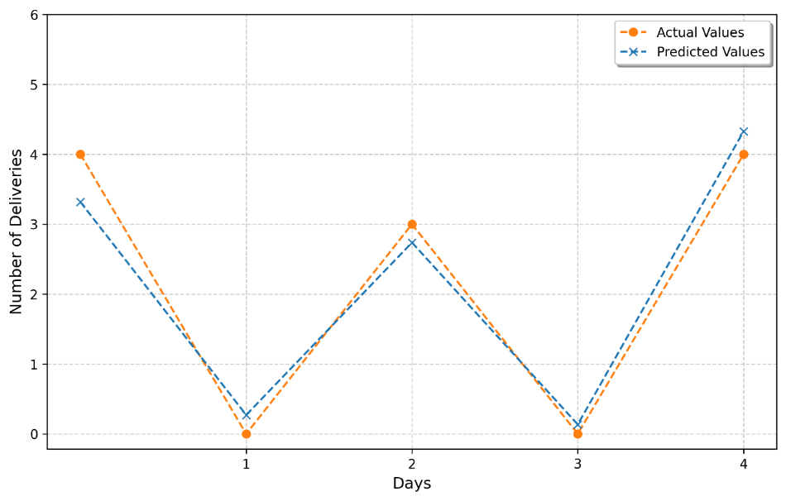
Figure 14 Cluster 1 prediction
MSE Loss | RMSE Loss | MAE Loss | R2 Score | Pearson's Correlation Coefficient
0.1466 | 0.3828 | 0.3357 | 0.9564 | 0.9804
Table 18 Cluster 1 prediction evaluation metrics

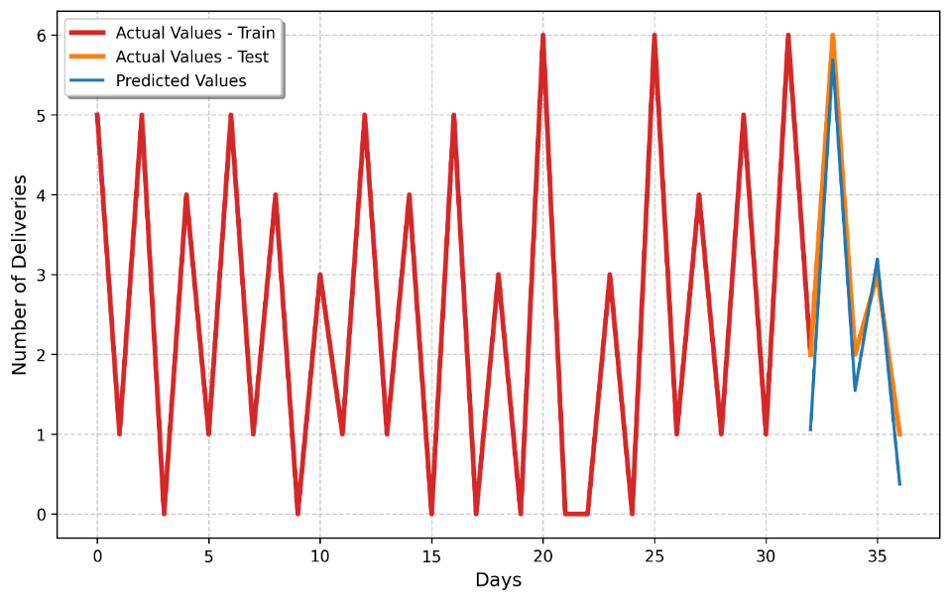
Figure 15 Cluster 0 time series forecasting
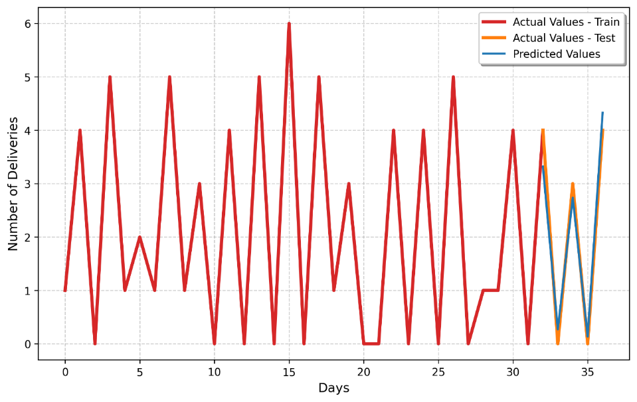
Figure 16 Cluster 1 time series forecasting
For the next steps, we assumed a value for number of deliveries prediction and continued with the analysis.

Synthetically generated new delivery locations
Even though we were able to predict the number of deliveries, we cannot say the from which delivery location and at what time the delivery order will be placed. Therefore, as mentioned in section 3.3.3, we generated the new locations using historical data and synthetically generated data. We assumed below values as the number of deliveries per each cluster.
Cluster 0 $→$ Test Prediction: 5 Cluster 1$→$ Test Prediction: 4
We calculated the mean for number of deliveries for each cluster before. We rounded down the mean to the nearest integer to get the mean number of deliveries.
Clusters | Mean | Rounded
0 | 2.567568 | 2
1 | 2.081081 | 2
Table 19 Mean of number of deliveries for each cluster
Next, we calculated the synthetic proportion for each cluster and generated new locations.
Cluster 0
Synthetic Locations = Predicted – Historical= 3
As Historical Proportion 2 locations were taken randomly from the cluster dataset. Before generating the synthetic locations, we calculated the mean of the delivery locations of that cluster which is the centroid of that cluster. So, remaining 3 Locations were generated using multi variate normal /Gaussian Distribution centered of centroid of the cluster and a spread of 0.003.
Method | Delivery location latitude | Delivery location longitude
Historical | 26.93365128 | 75.79498312
 | 26.90545551 | 75.82819559
Synthetical | 26.96964618 | 75.815806
 | 26.97791539 | 75.90679883
 | 26.92961492 | 75.81055484
Table 20 Cluster 0 predicted delivery locations to forecasted delivery demand
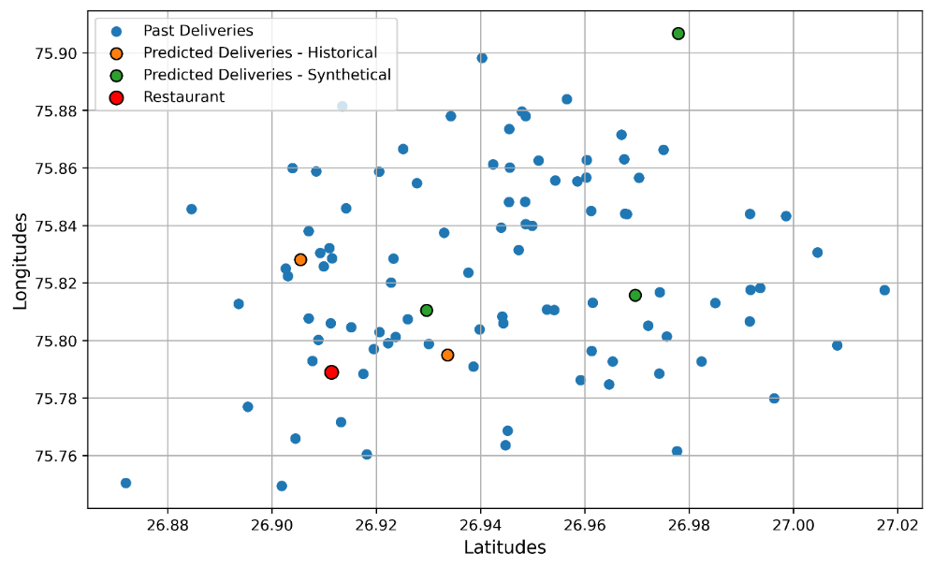
Figure 17 Cluster 0 predicted delivery locations to forecasted delivery demand
Cluster 1
Test Prediction: 4
Synthetic Locations = Predicted – Historical = 2
Same process discussed will be done for Cluster 0 will be done for cluster 1 to generate the synthetical locations.
Method | Delivery location latitude | Delivery location longitude
Historical | 26.99907599 | 75.90283352
 | 26.96134538 | 75.90774264
Synthetical | 27.1058773 | 75.9430447
 | 26.99366608 | 75.9307278
Table 21 Cluster 1 predicted delivery locations to forecasted delivery demand
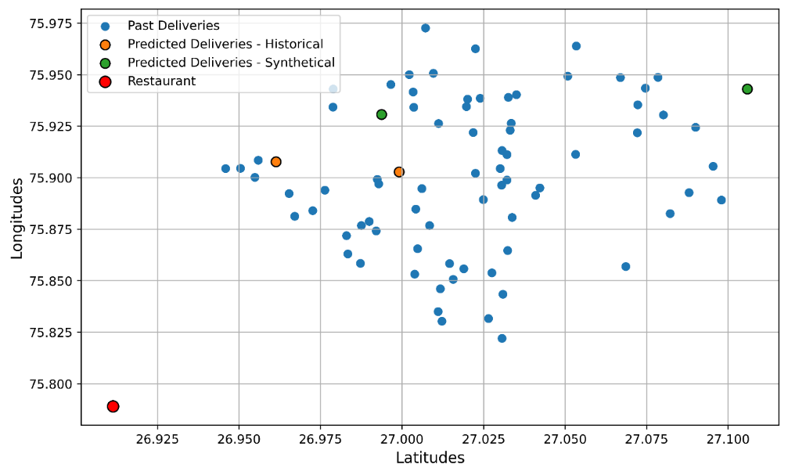
Figure 18 Cluster 1 predicted delivery locations to forecasted delivery demand

Delivery fleet optimization
After generating the new locations for each cluster, we randomly took type of orders and Time ordered details from the cluster dataset and assigned them to new locations. And then we added 40 minutes to the time ordered and created time delivery. Next, we converted time ordered and time delivery to seconds which created a sequential manner of time which is easy to compute using the VRP, and they are the time windows for the deliveries and type of order will be the customer demands. Then we converted type of order to weights as demands we assigned in section 3.3.4.1.3.
Location | Delivery location latitude | Delivery location longitude | Type of order | Time Ordered | Time Delivery | Start seconds | End seconds
Location 1 | 26.93365128 | 75.79498312 | Drinks | 11:25:00 AM | 12:05:00 PM | 41100 | 43500
Location 2 | 26.90545551 | 75.82819559 | Snack | 12:20:00 PM | 1:00:00 PM | 44400 | 46800
Location 3 | 26.96964618 | 75.815806 | Snack | 8:55:00 PM | 9:35:00 PM | 75300 | 77700
Location 4 | 26.97791539 | 75.90679883 | Meal | 10:30:00 PM | 11:10:00 PM | 81000 | 83400
Location 5 | 26.92961492 | 75.81055484 | Drinks | 12:00:00 PM | 12:40:00 PM | 43200 | 45600
Table 22 Cluster 0 VRP input dataset
Location | Demand
Restaurant | 0 (No Demand)
Location 1 | 2
Location 2 | 1
Location 3 | 1
Location 4 | 3
Location 5 | 2
Table 23 Cluster 0 VRP demands after order mapping
Location | Delivery location latitude | Delivery location longitude | Type of order | Time Ordered | Time Delivery | Start seconds | End seconds
Location 1 | 26.99907599 | 75.90283352 | Snack | 10:25:00 PM | 11:05:00 PM | 80700 | 83100
Location 2 | 26.96134538 | 75.90774264 | Buffet | 9:00:00 PM | 9:40:00 PM | 75600 | 78000
Location 3 | 27.1058773 | 75.9430447 | Meal | 9:50:00 PM | 10:30:00 PM | 78600 | 81000
Location 4 | 26.99366608 | 75.9307278 | Buffet | 7:25:00 PM | 8:05:00 PM | 69900 | 72300
Table 24 Cluster 1 VRP input dataset
Location | Demand
Restaurant | 0 (No Demand)
Location 1 | 1
Location 2 | 4
Location 3 | 3
Location 4 | 4
Table 25 Cluster 1 VRP demands after order mapping
Next, we calculated the travel distances and travel durations between restaurant and customers and customers and customers using Google Distance Matrix API. This is done for each cluster. We sent the required parameters to the API as it expected, and the API returned a JSON contains a matrix which has the travel distance and travel duration between each location (restaurant and customers) in SI units. Distances are measured in meters and the Durations are measured in seconds. Then we converted the JSON into two 2D matrix, Travel distances matrix and Travel durations matrix as below.
Travel Distances | Restaurant | Location 1 | Location 2 | Location 3 | Location 4 | Location 5
Restaurant | 0 | 3602 | 5903 | 10049 | 17423 | 4342
Location 1 | 4164 | 0 | 6418 | 6642 | 16079 | 2449
Location 2 | 5827 | 7246 | 0 | 13693 | 15652 | 4652
Location 3 | 9718 | 6036 | 11090 | 0 | 20789 | 7159
Location 4 | 17624 | 16175 | 15806 | 22397 | 0 | 14516
Location 5 | 3878 | 2798 | 4640 | 8186 | 14339 | 0
Table 26 Cluster 0 distance matrix
Travel Durations | Restaurant | Location 1 | Location 2 | Location 3 | Location 4 | Location 5
Restaurant | 0 | 580 | 1066 | 1635 | 2514 | 850
Location 1 | 671 | 0 | 1104 | 1112 | 2297 | 506
Location 2 | 968 | 1181 | 0 | 2236 | 1948 | 1040
Location 3 | 1619 | 1009 | 1956 | 0 | 3085 | 1293
Location 4 | 2660 | 2484 | 1973 | 3471 | 0 | 2224
Location 5 | 801 | 627 | 912 | 1480 | 2041 | 0
Table 27 Cluster 0 duration matrix

Travel Distances | Restaurant | Location 1 | Location 2 | Location 3 | Location 4
Restaurant | 0 | 19543 | 17132 | 32230 | 21428
Location 1 | 19341 | 0 | 8777 | 17830 | 4153
Location 2 | 17317 | 8776 | 0 | 25647 | 8020
Location 3 | 34785 | 20160 | 27882 | 0 | 22566
Location 4 | 20569 | 4153 | 6961 | 18397 | 0
Table 28 Cluster 1 distance matrix
Travel Durations | Restaurant | Location 1 | Location 2 | Location 3 | Location 4
Restaurant | 0 | 2752 | 2522 | 3367 | 2968
Location 1 | 2857 | 0 | 1231 | 1642 | 572
Location 2 | 2680 | 1274 | 0 | 2150 | 1075
Location 3 | 3653 | 1768 | 2257 | 0 | 1970
Location 4 | 3027 | 597 | 973 | 2098 | 0
Table 29 Cluster 1 duration matrix
Before running the VRP, we checked whether there are deliveries which cannot be achievable within the time of delivery and the travel duration is matched to that location from the restaurant is matched as discussed in section 3.3.4.3. This was ensuring every delivery was achievable from the restaurant without optimizing fleet. Otherwise, the model failed. We found some deliveries in both clusters, and we modified them as achievable deliveries.
Cluster 0 had only one delivery which is not achievable within the limit.
Location | Start Time | End Time | Duration | Start Time + Duration | New End Time
Location 4 | 81000 | 83400 | 2514 | 83514 | 83514
Table 30 Cluster 0 delivery feasibility check
For cluster 1, all the deliveries were not achievable within the limit.
Location | Start Time | End Time | Duration | Start Time + Duration | New End Time
Location 1 | 80700 | 83100 | 2752 | 83452 | 83452
Location 2 | 75600 | 78000 | 2522 | 78122 | 78122
Location 3 | 78600 | 81000 | 3367 | 81967 | 81967
Location 4 | 69900 | 72300 | 2968 | 72868 | 72868
Table 31 Cluster 1 delivery feasibility check
After the above checking, we ran the VRP Model for each E-Bike Type from the mentioned providers in section 3.3.4.4.1, 3.3.4.4.2, and 3.3.4.4.3. This was done for each cluster, and results from the output were as below. We show “EBIKE4DELIVERY” results here. “EVEEZ” and “RODHA” results are showed in Appendix.
For cluster 0,
Capacity | Distance | Number of Vehicles | Objective | Total Distance of Route | Total Load of Route
30 | 60000 | 1 | No Solution
30 | 60000 | 2 | 10346 | 64980 | 9
30 | 60000 | 3 | 10346 | 64980 | 9
30 | 60000 | 4 | 10346 | 64980 | 9
30 | 60000 | 5 | 10346 | 64980 | 9
30 | 60000 | 6 | 10346 | 64980 | 9
30 | 60000 | 7 | 10346 | 64980 | 9
30 | 60000 | 8 | 10346 | 64980 | 9
30 | 90000 | 1 | No Solution
30 | 90000 | 2 | 10346 | 64980 | 9
30 | 90000 | 3 | 10346 | 64980 | 9
30 | 90000 | 4 | 10346 | 64980 | 9
30 | 90000 | 5 | 10346 | 64980 | 9
30 | 90000 | 6 | 10346 | 64980 | 9
30 | 90000 | 7 | 10346 | 64980 | 9
30 | 90000 | 8 | 10346 | 64980 | 9
Table 32 Cluster 0 EBIKE4DELIVERY results
Best Parameters:
Objective value = 10346
Carrying capacity = 30
Maximum distance = 60000
Number of vehicles = 2
Route for vehicle 1:
Location | Arrival Window(s) | Delivery Load Done | Distance Covered(m)
Restaurant | [75680, 76065] | 0 | 0
Location 3 | [77615, 77700] | 0 | 10049
Location 4 | [81000, 81085] | 1 | 30838
Restaurant | [83660, 84045] | 4 | 48462
Table 33 Cluster 0 Gen2+ vehicle 1 route
Route for vehicle 2:
Location | Arrival Window(s) | Delivery Load Done | Distance Covered(m)
Restaurant | [41514, 42920] | 0 | 0
Location 1 | [42394, 43500] | 0 | 3602
Location 5 | [43200, 44306] | 2 | 6051
Location 2 | [44400, 45518] | 4 | 10691
Restaurant | [45368, 46786] | 5 | 16518
Table 34 Cluster 0 Gen2+ vehicle 2 route

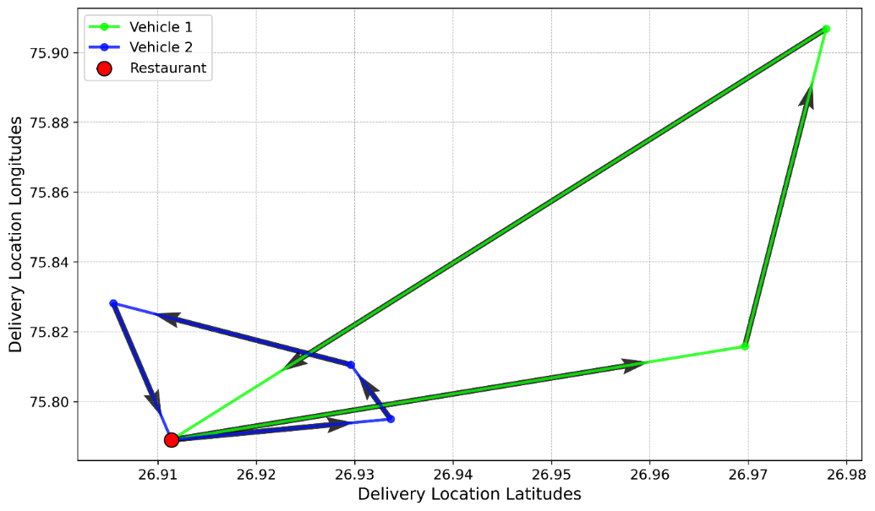
Figure 19 Cluster 0 Gen2+ vehicle routes
E-Bike Type | Vehicle | Total Distance Travelled(km) | Energy Consumption (kWh) | CO2 Emissions Saved (g)
Gen2+ | 1 | 48.462 | 0.581544 | 6396.984
 | 2 | 16.518 | 0.198216 | 2180.376
Total |  | 64.98 | 0.77976 | 8577.36
Table 35 Cluster 0 Gen2+ sustainability evaluation summary

For cluster 1,
Capacity | Distance | Number of Vehicles | Objective | Total Distance of Route | Total Load of Route
30 | 60000 | 1 | No Solution
30 | 60000 | 2
30 | 60000 | 3
30 | 60000 | 4
30 | 60000 | 5
30 | 60000 | 6
30 | 60000 | 7
30 | 60000 | 8
30 | 90000 | 1
30 | 90000 | 2 | 15292 | 124277 | 12
30 | 90000 | 3 | 15292 | 124277 | 12
30 | 90000 | 4 | 15292 | 124277 | 12
30 | 90000 | 5 | 15292 | 124277 | 12
30 | 90000 | 6 | 15292 | 124277 | 12
30 | 90000 | 7 | 15292 | 124277 | 12
30 | 90000 | 8 | 15292 | 124277 | 12
Table 36 Cluster 1 EBIKE4DELIVERY results
Best Parameters:
Objective value = 15292
Carrying capacity = 30
Maximum distance = 90000
Number of vehicles = 2
Route for vehicle 1:
Location | Arrival Window(s) | Delivery Load Done | Distance Covered(m)
Restaurant | [66632, 69900] | 0 | 0
Location 4 | [69900, 72868] | 0 | 21428
Restaurant | [72927, 76195] | 4 | 21428
Table 37 Cluster 1 Gen3 vehicle 1 route
Route for vehicle 2:
Location | Arrival Window(s) | Delivery Load Done | Distance Covered(m)
Restaurant | [73360, 75600] | 0 | 0
Location 2 | [76182, 78122] | 0 | 17132
Location 3 | [78632, 80572] | 4 | 42779
Location 1 | [80700, 82640] | 7 | 62939
Restaurant | [83557, 85797] | 8 | 82280
Table 38 Cluster 0 Gen3 vehicle 2 route
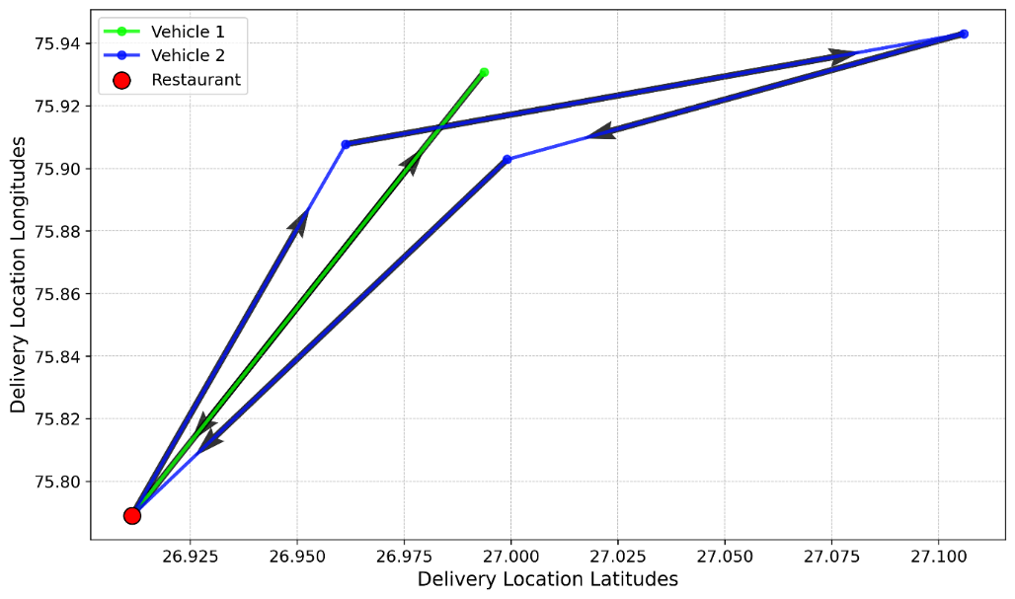
Figure 20 Cluster 1 Gen3 vehicle routes
E-Bike Type | Vehicle | Total Distance Travelled(km) | Energy Consumption (kWh) | CO2 Emissions Saved (g)
Gen3 | 1 | 41.997 | 0.41997 | 5543.604
 | 2 | 82.28 | 0.8228 | 10860.96
Total |  | 124.277 | 1.24277 | 16404.564
Table 39 Cluster 1 Gen3 sustainability evaluation summary

CHAPTER – DISCUSSION

Selecting the delivery records
As mentioned in section 3.2.1, we have a predefined values for starting date, ending date, staring time and ending time to select the records. For this analysis, since we need all the records, we defined minimum time and date and maximum time and date as starting and ending. But as mentioned in section 3.2.1, if restaurant wants to predict the customer delivery demand between 5pm and 9pm and optimize the fleet for that time frame, you can change the time frames and run the records, so the full model will run from the records between 5pm and 9pm. And what if there was a prevailing situation in the country and the restaurant ignore that occurred date range, they can simply change the starting and ending date as they wish, get the records and run the full model for that records and get insights.

Clustering delivery locations
Starting from clustering result, delivery locations were segregated into two zones. From the result, we can observe that the K-Means clustering has done a good work when the input data in location format which is latitudes and longitudes. Restaurant can determine 95 deliveries occurred from cluster 0 which is close to the restaurant location. The rest of 77 deliveries occurred from cluster 1 which is distant to the restaurant location. Since we start the k value from two, silhouette score for k=2 showed the maximum and we got the two clusters, as there are only 175 delivery records for the restaurant. As observed in the results, demand of the deliveries in the two clusters are different and both clusters have a dynamic nature in the number of deliveries daily. And since we need to deal with Fleet Optimization differently with these two clusters because of the distances, we need to predict the delivery demand separately to get a good accuracy compared to predicting the delivery demand for the whole restaurant. And if a restaurant has more deliveries around their delivery area and wants to divide their customers more than two zones, let’ say 3 zones, they can change the starting k to a value which is more than k. And if a restaurant management thinks, restaurant cannot have more than 6 zones because their resources are not enough, they can define starting k value as 3 and the maximum K value as 5. If we run our clustering for this kind of scenario it will show as this.
K | Silhouette scores
3 | 0.394223
4 | 0.414164
5 | 0.371535
6 | 0.348511
Table 40 Silhouette scores of experiments with restaurant requirement
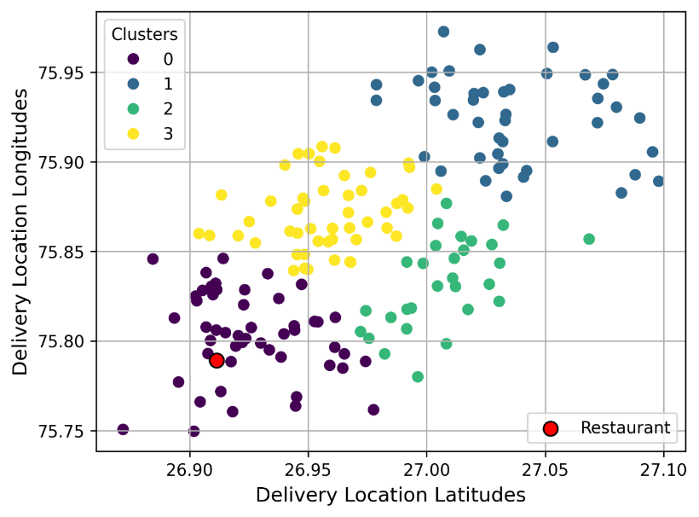
Figure 21 Clustering result of experiments with restaurant requirement
These scenarios occurs when a restaurant wants to expand their restaurant networks to the distant locations to handle the deliveries, like this chosen restaurant handles cluster 0 deliveries. Below plot shows centroids of each cluster for above new plot which we propose as new locations of restaurant network.
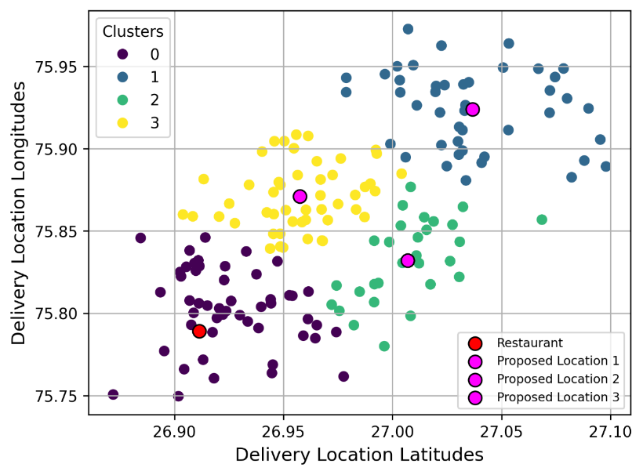
Figure 22 Proposed locations for the clustering result of experiments with restaurant requirement
This could minimize their operations costs of the restaurant’s delivery component and since we propose to integrate E-Bikes, E-Bikes can cover lot of deliveries before moving into recharging. Therefore, before predicting the demand as the first step, we must cluster the customer locations and predict and optimize the fleet differently for each cluster.

Delivery demand prediction
Through the LSTM model we proposed to predict the number of deliveries for a restaurant, observed results for each cluster were promising when testing the model. it proves LSTM an ideal Neural Network to predict the restaurant deliveries even when the data is highly fluctuated due to the dynamic nature of restaurant deliveries. Since we had a limited number of records (daily number of deliveries from 2022-03-01 to 2022-04-06 which is 37 days) and different sequence length for each cluster, the LSTM model couldn’t be trained to an optimal level. But through from this limited number of records and with two input features which is number of deliveries or day of the week, predictions we got as the results had a low loss (higher accuracy) compared to the other studies. Most interesting part was our model, it understood the trend of deliveries, which is the reason metrics was showing good results. To find the best values for the hyperparameters, we used Bayesian Optimization limited boundaries for each hyperparameter. Limited Boundaries was sufficient in this scenario, since we had limited number of records, and we predicted only one feature which is the number of deliveries for next day. But if the restaurant has more delivery records or the restaurant had a change in selecting records as mentioned in section 3.3.2.8, parameter boundaries should be changed as follows to cover any scenario.
Hyperparameter | Parameter Boundaries
Sequence length | [1, 7)
Hidden size | [2, 512)
Learning rate | (0.0001, 0.1)
Num of layers | [1, 10)
LSTM dropout | (0.0, 0.5)
FC dropout | (0.0, 0.5)
Epochs | [100, 1000)
Weight decay | (1e-08, 1e-02)
Table 41 Proposed hyperparameter boundaries for tuning

Hybrid location generation
As explained even though we predicted the number of deliveries for a restaurant for the next day, we cannot determine which customer from what location at what time will make the delivery order. But through this Mixture of Historical and Synthetic Locations, the restaurant will be able to get a good insight, where and when they can expect the orders. Both existing customers and new customers for the next day predicted delivery is dealt through our model. Restaurant Management can change the Spread value according to their decision like if they expect deliveries closer to centroid of the cluster or far away from the cluster. This could depend on the seasonal time or holidays which is again a management decision.

Delivery fleet optimization
When creating input dataset for VRP, we mapped the original orders from the dataset into numerical value which described their weights closely for our analysis. But restaurants can give more realistic values of their delivery items and map them accordingly. we gave 40 minutes from Time Ordered to Time of Delivery because restaurants have this hard time window as a standard. Through Google Distance Matrix API, we were able to get real life travel distances and travel durations for the deliveries in driving mode. But even without the fleet optimization, some of the deliveries was not able to be achieved through the 40 minutes time window because they were from distant locations. For Cluster 0, there was only 1 delivery, but for Cluster 1, all the deliveries were not achievable. Time Durations for these not achievable deliveries varied from 42 minutes to 56 minutes (which is +2 minutes and +16 minutes from standard delivery time). These scenarios can occur in real life as well. In the real-life scenario, what we do is we let the customer at the same time order is placed. But since this model, provides insights about optimization of delivery fleet, we just had to make sure all the deliveries are feasible and can be achieved without the model breaking. When running the Customized ERP for each E-Bike Types, we observed that after finding the objective value for the optimal combination of carrying capacity, range distance and number of vehicles, next combinations which belongs to the same e-bike type also gives the same objective value. For an example, when running the Customized VRP Model for EBIKE4DELIVERY E Bike Type Gen2+ for Cluster 0. model gives below output (objective value, total route distance, and total load) for the combinations of parameters.
Capacity | Distance | Number of Vehicles | Objective | Total Distance of Route | Total Load of Route
30 | 60000 | 1 | No Solution
30 | 60000 | 2 | 10346 | 64980 | 9
30 | 60000 | 3 | 10346 | 64980 | 9
30 | 60000 | 4 | 10346 | 64980 | 9
30 | 60000 | 5 | 10346 | 64980 | 9
30 | 60000 | 6 | 10346 | 64980 | 9
30 | 60000 | 7 | 10346 | 64980 | 9
30 | 60000 | 8 | 10346 | 64980 | 9
Table 42 Cluster 0 Gen2+ results
From this information we can observe that 2 Gen2+ E-Bikes from EBIKE4DELIVERY is sufficient to cover the deliveries. But if you observe the next combinations of Gen2+ Bikes gives the same objective and routes. This is because when we pass the more than the optimal number of vehicles, the model optimizes the fleet to into 2 Gen2+ E-Bikes and the rest will not be used for delivering. And because of that only 2 Gen2+ E-Bikes will be used and because of that, we get the same objective, Total Route distance for each. After running the VRP Model for next type Gen3 from EBIKE4DELIVERY, model finally outputs the optimal combination which gave the least objective value with least number of vehicles and prioritize the least cost E-bike model.
“Best Parameters: Carrying Capacity=30 Maximum Distance=60000 Number of Vehicles=2”
This is scenario is happening through out every run for other E-Bike Types as well. But our model intelligently output the optimal number of vehicles which the E-Bike Type is least cost for each provider. All three e-bikes providers final output has the same number of vehicles and routes and objectives because the route distances for each vehicle is less than every E-Bike distance range in all the E- Bike types and even though the carrying capacity of each E-Bike is changed which not really affecting because the route load smaller than every capacity of the 3 E-Bike types.
When it comes to Cluster 1 results, the only the high distance ranges e-bikes were given results because cluster 1 locations are distant from the restaurant location. Since RODHA model, which is a low range E-Bike, has only one model, they cannot be used in Cluster 1, because the VRP Model has not provide any solution for RODHA. Therefore, RODHA as a service provider cannot be used in distant delivery operations. EBIKE4DELIVERY and EVEEZ has at least one E-Bike model to perform in any cluster.
Using our final outputs of our customized VRP Model, Restaurant can make a joint operation using multiple providers. For an example, let’s assume a restaurant has multiple E-Bike providers which they can acquire services from. They can configure the E-Bike models in Our VRP Model and run the VRP model for each provider and find out the least cost E-Bike service provider to the predicted deliveries for each cluster of the customer locations. In our analysis, if our chosen restaurant be able to acquire services all the EBIKE4DELIVERY, EVEEZ and RODHA, RODHA would be ideal for cluster 0 and EBIKE4DELIVERY or EVEEZ is ideal for cluster 1.
From start to end, our whole model (clustering, forecasting, optimizing fleet and evaluating sustainability) is completely dynamic. Because of that, whole model can anticipate and mitigate any demand variation that can be happened time to time.

Sustainability evaluation of integrating E-Bikes to the deliveries
Integration of E-Bikes to the delivery fleet was the final idea of the model by optimizing the delivery which will reduce whole delivery operational cost. From the Energy Consumption results for each provider, best vehicle with low battery capacity is ideal for cluster 0 as which the deliveries can be achieved by shorter trips. But for Cluster 1, the restaurant needs higher battery capacity E-Bikes such as “Gen3” or “BLAZE” because they can cover distant range.
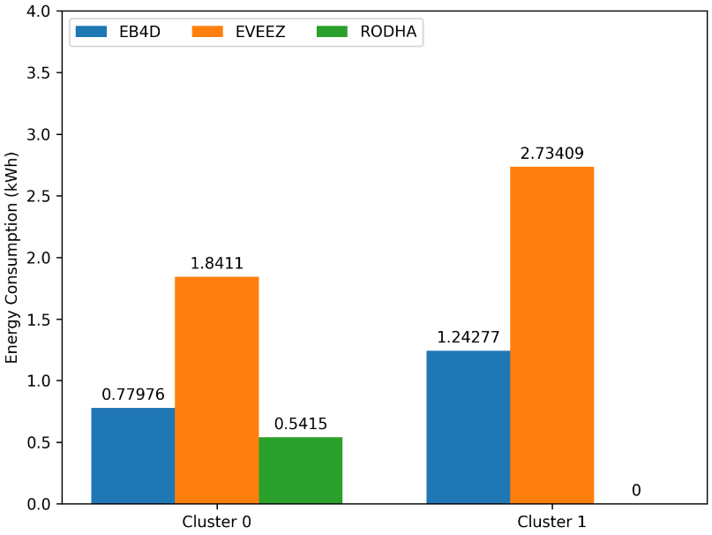
Figure 23 Energy consumption comparison of E-Bikes for each cluster
If the restaurant analysis, how the energy is consumed within each vehicle, they can use the same bike twice by recharging again if the restaurant has the charging facility. But if the E-Bikes needed to be got to the recharging facility of the provider, they can evaluate the how much is needed and pay for that amount only. Because of these considerations, restaurants can monitor the predicted energy consumption through our model and get insights on how to recharge or reuse the E-Bike which leads the restaurant implement energy savings initiatives.
On the other hand, if the restaurant used to traditional motor bike or scooter, CO2 Emissions will be increasing day by day which ultimately leads to the pollution. But since we integrate E-Bikes, we can assess how much CO2 has been reduced. Since Cluster 0 and Cluster 1 has same routes and route distances as we mentioned in section 4.9, CO2 Emission saved for each E-Bike is mostly same. From the results, if we choose one E-Bike type, we can observe that approximately 25kg CO2 emissions have been reduced due to the integration of E-Bikes. Restaurants could use this insight to show the respective parties to win over future incentives to initiating sustainable practices.
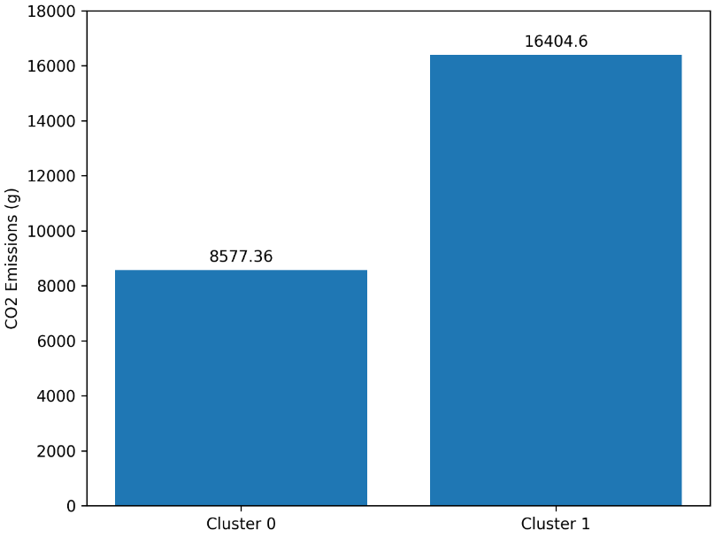
Figure 24 CO2 emission saved per each cluster

CHAPTER – CONCLUSION AND FUTURE RESEARCH
Through our model’s final outputs of each section, restaurant management who are working under self-logistics can get insights on below questions.
- How are the past customers distributed among the delivery area?
- What are the different zones of the delivery area?
- how can the restaurant be expanded to other zones of the delivery?
- How much will be the demand for the next day? (for a particular time frame and/or order type)
- How much E-Bikes will be needed as optimized fleet is required for the predicted demand?
- What is the best E-Bike model from different providers?
- How much Energy will be consumed, and CO2 Emissions will be saved by choosing the best E-Bike model?
These insights will be extremely useful for restaurant management, for identify the delivery customers, expanding the restaurant network, optimizing the restaurant’s resources, better capacity planning, efficient and sustainable procurement for raw materials, efficient inventory management, acquiring the delivery fleet of E-Bikes, efficient deliveries and sustainable initiatives. Since this model can be run through any E-Bike model, if the E-Bike carrying capacity and distance range is given. As per our results, it was reflecting 3 countries E-Bikes performances on the predicted locations. Because of the model’s dynamic nature, any restaurant can integrate this model to their existing platform or create new one with the idea of this. Through the sustainable measures, restaurant can request for tax reliefs and incentives from government and the restaurant can go for different international sustainable standards as well.
This model can be generalized for any kind of restaurant or any sector in the hospitality industry. Due to complete dynamic model experience, any sector, which needs to have a delivery can use this model and get insights on deliveries. If this is used by pharmaceutical delivery company, they need to add the location of the pharmaceutical company and change the order type mapping to pharmaceutical materials. They can even change the E-Bike model to another freight vehicle such as truck and update the model with carrying capacity and vehicle distance range according to the fuel consumption. Since the pharmaceutical delivery company usually have the historical records for pharmaceutical deliveries, they run the whole process of the model and get all the insights for the mentioned questions in the beginning of this section, but for pharmaceutical delivery company.
For future research, this forecasting model can be improved further by adding more features such as holidays and per capita income of the country to increase the model’s accuracy on more realistic situations. And for the Customized VRP model can be improved, to integrate pricing strategies for deliveries, to handle shifts for restaurant delivery drivers, to use the same E-Bike if the Battery Capacity is feasible to go another round of deliveries and to handle pick up and deliveries as well for outsourced drivers’ scenario for the restaurant. This model can be extended to use drones for the delivery as well by changing the distance measurements of the Customized VRP.

REFERENCES
Abdullahi, M.R., Lu, Q.C., Hussain, A., Tripura, S., Xu, P.C., Wang, S.X., 2024. Location optimization of EV charging stations: A custom K-means cluster algorithm approach. Energy Reports 12, 5367–5382. https://doi.org/10.1016/j.egyr.2024.09.075
Álvarez, P., Serrano-Hernandez, A., Lerga, I., Faulin, J., 2024. Optimizing freight delivery routes: The time-distance dilemma. Transp Res Part A Policy Pract 190. https://doi.org/10.1016/j.tra.2024.104283
Auad, R., Erera, A., Savelsbergh, M., 2024. Capacity requirements and demand management strategies in meal delivery. EURO Journal on Transportation and Logistics 13. https://doi.org/10.1016/j.ejtl.2024.100135
Chae, B. (Kevin), Sheu, C., Park, E.O., 2024. The value of data, machine learning, and deep learning in restaurant demand forecasting: Insights and lessons learned from a large restaurant chain. Decis Support Syst 184. https://doi.org/10.1016/j.dss.2024.114291
Dinh, D.-T., Fujinami, T., Huynh, V.-N., 2019. Estimating the Optimal Number of Clusters in Categorical Data Clustering by Silhouette Coefficient, in: Chen, J., Huynh, V.N., Nguyen, G.-N., Tang, X. (Eds.), Knowledge and Systems Sciences. Springer Singapore, Singapore, pp. 1–17.
Du, Z., Fan, Z.P., Sun, F., 2023. O2O dual-channel sales: Choices of pricing policy and delivery mode for a restaurant. Int J Prod Econ 257. https://doi.org/10.1016/j.ijpe.2022.108766
EBIKE4DELIVERY, 2025. E4D Ebike4Delivery - E-Bike Solutions for all your deliveries [WWW Document]. EBIKE4DELIVERY . URL https://www.ebike4delivery.com/ (accessed 4.28.25).
EVEEZ, 2020. EVEEZ - eBikes on rent near you [WWW Document]. EVEEZ. URL https://www.eveez.in/eBikes-on-rent (accessed 4.28.25).
Goulias, K.G., Shi, H., 2023. Commercial Fleet Vehicle Additions and Replacements and the Potential Market Penetration for Electric Vehicles, in: Transportation Research Procedia. Elsevier B.V., pp. 69–76. https://doi.org/10.1016/j.trpro.2023.11.003
Hess, A., Spinler, S., Winkenbach, M., 2021. Real-time demand forecasting for an urban delivery platform. Transp Res E Logist Transp Rev 145. https://doi.org/10.1016/j.tre.2020.102147
Hinton, G.E., Srivastava, N., Krizhevsky, A., Sutskever, I., Salakhutdinov, R., 2012. Improving neural networks by preventing co-adaptation of feature detectors. CoRR abs/1207.0580.
Hsu, C.I., Chen, W.T., 2014. Optimizing fleet size and delivery scheduling for multi-temperature food distribution. Appl Math Model 38, 1077–1091. https://doi.org/10.1016/j.apm.2013.07.036
Huang, Y., Qian, L., Soopramanien, D., Tyfield, D., 2021. Buy, lease, or share? Consumer preferences for innovative business models in the market for electric vehicles. Technol Forecast Soc Change 166. https://doi.org/10.1016/j.techfore.2021.120639
Kaczmarski, M., 2024. Which company is winning the restaurant food delivery war? [WWW Document]. Bloomberg Second Measure. URL https://secondmeasure.com/datapoints/food-delivery-services-grubhub-uber-eats-doordash-postmates/ (accessed 4.29.25).
Khalid, H., 2025. Online Food Ordering and Delivery Platform for Restaurants [WWW Document]. ENATEGA. URL https://enatega.com/online-food-ordering-and-delivery-platform/ (accessed 4.29.25).
Khan, A., 2024. How McDonald’s Stays Ahead of the Game: The Genius of Data Analytics [WWW Document]. medium.com. URL https://medium.com/@aa.khan.9093/how-mcdonalds-stays-ahead-of-the-game-the-genius-of-data-analytics-f1160ca3e806 (accessed 5.1.25).
Kyriakakis, N.A., Stamadianos, T., Marinaki, M., Marinakis, Y., 2022. The electric vehicle routing problem with drones: An energy minimization approach for aerial deliveries. Cleaner Logistics and Supply Chain 4. https://doi.org/10.1016/j.clscn.2022.100041
Lazcano, A., Jaramillo-Morán, M.A., 2025. Data preprocessing techniques and neural networks for trended time series forecasting. Appl Soft Comput 174. https://doi.org/10.1016/j.asoc.2025.113063
Malik, G., 2022. Food Delivery Dataset [WWW Document]. URL https://www.kaggle.com/datasets/gauravmalik26/food-delivery-dataset
Matsuyuki, M., Chotib, Nurhasana, R., Antokida, Y., Fitrinitia, I.S., Made Shellasih, N., Rizky Ningtyas, F., 2024. Assessment of the sustainability of online food delivery from the perspective of CO2 emissions and transport intensity: A case study in Jakarta. Transp Res Interdiscip Perspect 27, 101200. https://doi.org/10.1016/j.trip.2024.101200
Niu, B., Li, Q., Mu, Z., Chen, L., Ji, P., 2021. Platform logistics or self-logistics? Restaurants’ cooperation with online food-delivery platform considering profitability and sustainability. Int J Prod Econ 234. https://doi.org/10.1016/j.ijpe.2021.108064
Nogueira, F., 2014. Bayesian Optimization: Open source constrained global optimization tool for Python.
Oyeyemi Olayode, I., Jamei, E., Justice Alex, F., 2025. Integration of e-bikes in public transportation based on their impact, importance, and challenges: A systematic review. Multimodal Transportation. https://doi.org/10.1016/j.multra.2024.100182
Park, S., Yoo, S.H., 2022. Government intervention in environmental performance considering working capital issues: Control the supplier or the buyer? Comput Ind Eng 163. https://doi.org/10.1016/j.cie.2021.107790
Paszke, A., Gross, S., Massa, F., Lerer, A., Bradbury, J., Chanan, G., Killeen, T., Lin, Z., Gimelshein, N., Antiga, L., Desmaison, A., Köpf, A., Yang, E., DeVito, Z., Raison, M., Tejani, A., Chilamkurthy, S., Steiner, B., Fang, L., Bai, J., Chintala, S., 2019. PyTorch: an imperative style, high-performance deep learning library. Proceedings of the 33rd International Conference on Neural Information Processing Systems.
Pattanshetty, S., 2023. THE IMPACT OF ONLINE FOOD DELIVERY PLATFORMS ON THE GROWTH AND PROFITABILITY OF RESTAURANTS IN INDIA. IJFANS INTERNATIONAL JOURNAL OF FOOD AND NUTRITIONAL SCIENCES 12, Iss 01.
Pedregosa, F., Varoquaux, G., Gramfort, A., Michel, V., Thirion, B., Grisel, O., Blondel, M., Prettenhofer, P., Weiss, R., Dubourg, V., Vanderplas, J., Passos, A., Cournapeau, D., Brucher, M., Perrot, M., Duchesnay, É., 2011. Scikit-learn: Machine Learning in Python. Journal of Machine Learning Research.
Prencipe, L.P., Colovic, A., Binetti, M., Ottomanelli, M., 2024. Zero-emission vehicle adoption towards sustainable e-grocery last-mile delivery. Research in Transportation Economics 104. https://doi.org/10.1016/j.retrec.2024.101429
RODHA AT, 2022. Electric Bikes - RODHA Life [WWW Document]. RODHA AT. URL https://rhoda.life/ (accessed 4.28.25).
Sadati, M.E.H., Akbari, V., Çatay, B., 2022. Electric vehicle routing problem with flexible deliveries. Int J Prod Res 60, 4268–4294. https://doi.org/10.1080/00207543.2022.2032451
Salama, M., Srinivas, S., 2020. Joint optimization of customer location clustering and drone-based routing for last-mile deliveries. Transp Res Part C Emerg Technol 114, 620–642. https://doi.org/10.1016/j.trc.2020.01.019
Sandland, M., 2024. Restaurant Delivery: The Old Way vs The New Way | Modern Restaurant Management | The Business of Eating & Restaurant Management News [WWW Document]. Modern Restaurant Management. URL https://modernrestaurantmanagement.com/restaurant-delivery-the-old-way-vs-the-new-way/
Schmidt, A., Kabir, M.W.U., Hoque, M.T., 2022. Machine Learning Based Restaurant Sales Forecasting. Mach Learn Knowl Extr. https://doi.org/10.3390/make4010006
Tanizaki, T., Shimmura, T., Kataoka, T., 2024. Forecasting the number of customers visiting restaurants in COVID-19, in: Procedia CIRP. Elsevier B.V., pp. 20–55. https://doi.org/10.1016/j.procir.2024.08.255
Tripathi, S.K., Kant, R., Shankar, R., 2025. Investigating the electric vehicle adoption initiatives for achieving sustainable development goals. Sustainable Futures 9. https://doi.org/10.1016/j.sftr.2025.100469
Ubal, C., Di-Giorgi, G., Contreras-Reyes, J.E., Salas, R., 2023. Predicting the Long-Term Dependencies in Time Series Using Recurrent Artificial Neural Networks. Mach Learn Knowl Extr 5, 1340–1358. https://doi.org/10.3390/make5040068
Wang, J., Guo, P., Wang, Y., Zhang, L., 2024. How should restaurants operate in the omnichannel era? A queueing game approach. Int J Prod Econ 274. https://doi.org/10.1016/j.ijpe.2024.109306
Wang, N., Xu, Y., Puška, A., Stević, Ž., Alrasheedi, A.F., 2023. Multi-Criteria Selection of Electric Delivery Vehicles Using Fuzzy–Rough Methods. Sustainability (Switzerland) 15. https://doi.org/10.3390/su152115541
Yao, P., Osman, S., Sabri, M.F., Zainudin, N., Li, Y., 2023. Do consumers continue to use O2O food delivery services in the post-pandemic era? Roles of sedentary lifestyle. Heliyon 9. https://doi.org/10.1016/j.heliyon.2023.e19131
Zhang, Y., Kasraian, D., van Wesemael, P., 2025. E-bike ownership and use determinants and their trends in the Netherlands. J Transp Geogr 125. https://doi.org/10.1016/j.jtrangeo.2025.104203

APPENDIX

EVEEZ fleet optimization

Cluster 0
Capacity | Distance | Number of Vehicles | Objective | Total Distance of Route | Total Load of Route
120 | 60000 | 1 | No Solution
120 | 60000 | 2 | 10346 | 64980 | 9
120 | 60000 | 3 | 10346 | 64980 | 9
120 | 60000 | 4 | 10346 | 64980 | 9
120 | 60000 | 5 | 10346 | 64980 | 9
120 | 60000 | 6 | 10346 | 64980 | 9
120 | 60000 | 7 | 10346 | 64980 | 9
120 | 60000 | 8 | 10346 | 64980 | 9
70 | 100000 | 1 | No Solution
70 | 100000 | 2 | 10346 | 64980 | 9
70 | 100000 | 3 | 10346 | 64980 | 9
70 | 100000 | 4 | 10346 | 64980 | 9
70 | 100000 | 5 | 10346 | 64980 | 9
70 | 100000 | 6 | 10346 | 64980 | 9
70 | 100000 | 7 | 10346 | 64980 | 9
70 | 100000 | 8 | 10346 | 64980 | 9
Table 43 Cluster 0 EVEEZ results
Best Parameters:
Objective value = 10346
Carrying capacity = 30
Maximum distance = 60000
Number of vehicles = 2
Route for vehicle 1:
Location | Arrival Window(s) | Delivery Load Done | Distance Covered(m)
Restaurant | [75680, 76065] | 0 | 0
Location 3 | [77615, 77700] | 0 | 10049
Location 4 | [81000, 81085] | 1 | 30838
Restaurant | [83660, 84045] | 4 | 48462
Table 44 Cluster 0 SHINE vehicle 1 route
Route for vehicle 2:
Location | Arrival Window(s) | Delivery Load Done | Distance Covered(m)
Restaurant | [41514, 42920] | 0 | 0
Location 1 | [42394, 43500] | 0 | 3602
Location 5 | [43200, 44306] | 2 | 6051
Location 2 | [44400, 45518] | 4 | 10691
Restaurant | [45368, 46786] | 5 | 16518
Table 45 Cluster 0 SHINE vehicle 2 route

Figure 25 Cluster 0 SHINE vehicle routes
E-Bike Type | Vehicle | Total Distance Travelled(km) | Energy Consumption(kWh) | CO2 Emissions Saved(g)
SHINE | 1 | 48.462 | 1.37309 | 6396.984
 | 2 | 16.518 | 0.46801 | 2180.376
Total |  | 64.98 | 1.8411 | 8577.36
Table 46 Cluster 0 SHINE sustainability evaluation summary

Cluster 1
Cluster | Capacity | Distance | Number of Vehicles | Objective | Total Distance of Route | Total Load of Route
1 | 120 | 60000 | 1 | No Solution
1 | 120 | 60000 | 2
1 | 120 | 60000 | 3
1 | 120 | 60000 | 4
1 | 120 | 60000 | 5
1 | 120 | 60000 | 6
1 | 120 | 60000 | 7
1 | 120 | 60000 | 8
1 | 70 | 100000 | 1
1 | 70 | 100000 | 2 | 15292 | 124277 | 12
1 | 70 | 100000 | 3 | 15292 | 124277 | 12
1 | 70 | 100000 | 4 | 15292 | 124277 | 12
1 | 70 | 100000 | 5 | 15292 | 124277 | 12
1 | 70 | 100000 | 6 | 15292 | 124277 | 12
1 | 70 | 100000 | 7 | 15292 | 124277 | 12
1 | 70 | 100000 | 8 | 15292 | 124277 | 12
Table 47 Cluster 1 EVEEZ results
Best Parameters:
Objective value = 15292
Carrying capacity = 30
Maximum distance = 90000
Number of vehicles = 2
Route for vehicle 1:
Location | Arrival Window(s) | Delivery Load Done | Distance Covered(m)
Restaurant | [66632, 69900] | 0 | 0
Location 4 | [69900, 72868] | 0 | 21428
Restaurant | [72927, 76195] | 4 | 21428
Table 48 Cluster 1 BLAZE vehicle 1 route
Route for vehicle 2:
Location | Arrival Window(s) | Delivery Load Done | Distance Covered(m)
Restaurant | [73360, 75600] | 0 | 0
Location 2 | [76182, 78122] | 0 | 17132
Location 3 | [78632, 80572] | 4 | 42779
Location 1 | [80700, 82640] | 7 | 62939
Restaurant | [83557, 85797] | 8 | 82280
Table 49 Cluster 1 BLAZE vehicle 2 route

Figure 26 Cluster 1 BLAZE vehicle routes
E-Bike Type | Vehicle | Total Distance Travelled(km) | Energy Consumption (kWh) | CO2 Emissions Saved (g)
BLAZE | 1 | 41.997 | 0.923934 | 5543.604
 | 2 | 82.28 | 1.81016 | 10860.96
Total |  | 124.277 | 2.734094 | 16404.564
Table 50 Cluster 1 BLAZE sustainability evaluation summary

RODHA fleet optimization

Cluster 0
Capacity | Distance | Number of Vehicles | Objective | Total Distance of Route | Total Load of Route
25 | 60000 | 1 | No Solution
25 | 60000 | 2 | 10346 | 64980 | 9
25 | 60000 | 3 | 10346 | 64980 | 9
25 | 60000 | 4 | 10346 | 64980 | 9
25 | 60000 | 5 | 10346 | 64980 | 9
25 | 60000 | 6 | 10346 | 64980 | 9
25 | 60000 | 7 | 10346 | 64980 | 9
25 | 60000 | 8 | 10346 | 64980 | 9
Table 51 Cluster 0 RODHA results
Best Parameters:
Objective value = 10346
Carrying capacity = 30
Maximum distance = 60000
Number of vehicles = 2
Route for vehicle 1:
Location | Arrival Window(s) | Delivery Load Done | Distance Covered(m)
Restaurant | [75680, 76065] | 0 | 0
Location 3 | [77615, 77700] | 0 | 10049
Location 4 | [81000, 81085] | 1 | 30838
Restaurant | [83660, 84045] | 4 | 48462
Table 52 Cluster 0 RODHA vehicle 1 route
Route for vehicle 2:
Location | Arrival Window(s) | Delivery Load Done | Distance Covered(m)
Restaurant | [41514, 42920] | 0 | 0
Location 1 | [42394, 43500] | 0 | 3602
Location 5 | [43200, 44306] | 2 | 6051
Location 2 | [44400, 45518] | 4 | 10691
Restaurant | [45368, 46786] | 5 | 16518
Table 53 Cluster 0 RODHA vehicle 2 route

Figure 27 Cluster 0 RODHA vehicle routes
E-Bike Type | Vehicle | Total Distance Travelled(km) | Energy Consumption | CO2 Emissions Saved
RODHA | 1 | 48.462 | 0.40385 | 6396.984
 | 2 | 16.518 | 0.13765 | 2180.376
Total |  | 64.98 | 0.5415 | 8577.36
Table 54 Cluster 0 RODHA sustainability evaluation summary

Cluster 1
Capacity | Distance | Number of Vehicles | Objective | Total Distance of Route | Total Load of Route
25 | 60000 | 1 | No Solution
25 | 60000 | 2
25 | 60000 | 3
25 | 60000 | 4
25 | 60000 | 5
25 | 60000 | 6
25 | 60000 | 7
25 | 60000 | 8
Table 55 Cluster 1 RODHA results

